RAMESH
RAMESH.334822@2freemail.com

EXECUTIVE SECRETARY / ASSISTANT & OFFICE ADMINISTRATOR PROFILE- offering several Years of experience
Professional Profile

~Skilled professional with focused approach to work and comfortable in liaising with people at any level of business; experienced in leading large, cross-functional and multi-disciplinary teams while achieving goals and business objectives in time-sensitive environment
~Dexterously delivered training to the EAs to bring out the best in them and provided seamless support to Partners & Directors. Along with it supported partners individually (4 partners).

- Presently working with McKinsey & Company as TL & EXECUTIVE ASSISTANT to Associate Partners and Partners. Trusted service record with 4004 Inc. (Steve And Barry’s University Sportswear ) Mumbai as EXECUTIVE SECRETARY to MD India / Purchase Executive – Projects; Thomas Cook Exchange Co. Abu Dhabi as EXECUTIVE SECRETARY to Branch Head /Administration Officer and many other companies
- Expert in making appointments and organizing Directors calendars, conferences, seminars and meetings with clients. Arranging travel plans, itinerary, visas, ticketing, hotel reservations & car rentals for Partners. Managing e-mails, faxes, couriers, correspondences, and transmit telex messages and networking with the media and press for release of advertisements and articles.
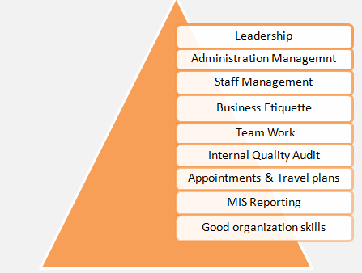
- Scrupulous and highly skilled professional with experience in handling and leading team; maintaining confidential Information at all levels and communication; ensuring team work is optimal and building a great understanding within the team members by organizing team events and outings and dinners; maintaining good relations with the client and performing many other activities as assigned by management
- Skilled in executing Internal Quality Audit per ISO 9002; authorized signatory for approval of drafts and conducting orientation programs
- Self-motivated, hardworking and goal oriented with a high degree of flexibility, creativity, resourcefulness, commitment and optimism

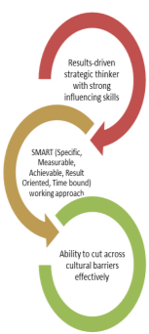
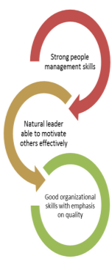
Professional Credentials & Domain Skills

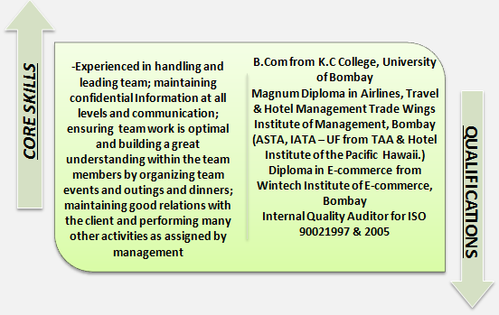

FOUNDATIONAL STRENGTH
High level Executive Secretarial support| Team Management | Supervision | Staff Management| Quality Standards | MIS reports | Appointments & Travel plans| Internal Quality Audit | Client Coordination | Worked on TA appraisals | Leadership Acumen| Training & development| Client Meetings | Calendar Management | Project Planning | Liaison & Coordination | Vendors Management

Work Experience

April 2007 — with McKinsey & Company Mumbai, India as TL & EXECUTIVE ASSISTANT to Associate Partners and Partners

Worked on the project of setting up the West Coast Team Assistants initiative for the US and successfully took over as Team Coordinator after a span of 10 months; lead the team in supporting EMs in the West Coast offices and moved over to setting up the pilot project of providing remote EA support to partners in the Middle East Office. Dexterously worked and took over as Team Leader for the remote Mumbai EA support group.
Key Result Areas
- Ensuring and providing all the support that a Partner needs as any other local Executive Assistant. Such as daily calendar & conflict management, setting up client meetings, replying on emails on behalf of the Partner, Alerting Partners on critical emails which go unnoticed, travel bookings for partners, hotel reservations, formal and informal dinner bookings, visas submissions & renewals
- Accountable for arranging video conferences with client and internally, submitting time sheets on behalf of the partner, partner’s expenses claims, medical claims, filing, working on arranging all the required documents for submission of LOPs to clients for new projects and taking care of the logistics of submission of the documents in the required format before the deadline.
- Maintaining good relations with the client. Utilizing safe work practices and following directives, policies and procedures for assisting and maintaining a healthy and safe work environment as outlined.
- Delivering training and mentoring to existing and new EAs to bring out the best in them and providing seamless support to the Middle East Offices. Guiding & mentoring staff members in accomplishment of business objectives; improving the team performance through counseling, skills enhancement. Setting up team priorities & performance objectives, reviewing the employee’s performance
- Accountable for ensuring team work is optimal and building a great understanding within the team members by organizing team events and outings and dinners along with it working on yearly appraisals of the EA team by coordinating with Middle East Offices and Mumbai office.
- Delivering regular feedback to the teams as and when required and ensuring all developmental areas are worked on by the team member. Supervising and monitoring the performance level of the staff for ensuring accomplishment of target. Organizing regular periodic meetings & trainings to staff for discussing current work issues and devised solutions

April 2000 — December 2006 with 4004 Inc. (Steve And Barry’s University Sportswear) Mumbai, India as EXECUTIVE SECRETARY to MD - India /Purchase Executive - Projects

Started as an Executive Secretary to the MD India and later on also entered into projects. Succeeded in setting up 100 stores

Key Result Areas
- Providing complete Secretarial and Admin support to the MD. Taking care of his calendar, meetings, emails, expenses, travel, hotel, video conferences and any other ad hoc project as when needed by the management.
- Monitored and ensured that the quality of work assigned is excellent and complies well with the norms by doing internal audits.
- Reported to the MD in the Mumbai office and also to the Chairman in the New York office. Also worked in projects as Purchase Executive reporting to the purchase Manager & MD.
- Performed the project planning for the new stores coming up in the US by outsourcing various utilities such as furniture’s, fixtures, accessories and placing orders and also sourced contractors for setting up store and tracking material for stores.
- Coordinated with vendors from all over the world and negotiating deals along with it acted as Certified Internal Quality Auditor for ISO in this organization
- Maintained first-level quality assurance to confirm that the installation of all work within the discipline is in accordance with the plans, specifications, and industry standards.
- Accountable for maintaining continuous alignment of business operations scope with strategic business objectives, and providing recommendations to modify & enhanced effectiveness toward business result or strategic intent.

PreviousEngagements

April 1999 — September 1999 with H.S.B.C. Mumbai, India as Administration Officer (General & Correspondence) – CPD (Temp Assign.)

June 1996 — March 1999 with Thomas Cook Exchange Co. Abu Dhabi, U.A.E as EXECUTIVE SECRETARY –CUM –ADMINISTRATION OFFICER to Branch Head

Assisted the Branch Head in the regular secretarial activities and administration of the branch along with it I was selected by the company and ISO to be an Internal Quality auditor. I was also an Authorized signatory for issuance of drafts as well. Emulating the role of the branch manager in his absence, the cost control of utilities & amenities, this was achieved by keeping a check on unnecessary utilization of office materials. Perusal of travelers’ cheque settlements and remittance with Midland bank & Bank of New York.

April 1994 — March 1996 with Muller & Phipps (I) Ltd., Mumbai, India as SECRETARY TO VP Sales & ADMIN EXECUTIVE Sales

Assisted the V.P. Sales, did some correspondence with clients & distributors, coordinated with the branches for quarterly sales report. I had to prepare MIS reports as per sales in each region. I did support for the sales dept. with their sales calls and attend calls pertaining to sales and redirecting them to the appropriate personnel. On this job I also learned to transmit telex messages

Education&Credentials

- 1992 B.Com from K.C College, University of Bombay
- 1994 Magnum Diploma in Airlines, Travel & Hotel Management Trade Wings Institute of Management, Bombay (ASTA,
IATA – UF from TAA & Hotel Institute of the Pacific Hawaii.)
- 2000 Diploma in E-commerce from Wintech Institute of E-commerce, Bombay

Others
- Internal Quality Auditor for ISO 90021997 & 2005

IT Skills: SAP; Microsoft Word, Excel & PowerPoint and

Personal Details

- Date of Birth:25th March, 1971
- Linguistic Abilities: English, Hindi (Spoken and written), Malayalam, Marathi

