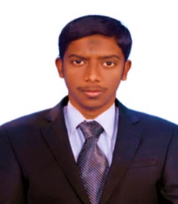
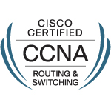
JASSIM
IT ADMINISTRATOR
Jassim.334824@2freemail.com

OBJECTIve |  |  | To work in an environment that utilizes my IT skills and experience where I can enhance my Professional skills in the accomplishment of Company goal.
EXPERIENCE |  |  | GLOBAL INFO-TECH  Desktop Support Engineer  JUL-2015 to AUG-2016  Responsibilities:  - Computer assembling and maintenance.  - Installation and configuration of the peripherals, components and drivers.  - Installing software and application to user standards in Laptops and Desktops.  - Configuring and troubleshooting desktops, laptops and servers.  - Excellent troubleshooting skills in complex software and hardware problems.  - Installing Hard disks, CD Drives, Sound Blaster cards, CPU, Memory, Power supply unit, Network card, Video graphics card, Hard disk controller card on PC systems.  - CAT5, CAT6 RJ45 Cable Crimping.  - Operating System : Windows 7, Windows 8, Windows 10  - Packages: MS- Office 2010, Photoshop.
Education |  |  | MASTER OF SCIENCE – M.SC (I.T) from The University of Madras, India with 74% in 2015.  BACHELOR OF SCIENCE – B.SC (C.S) from the Bharathidasan University, India with 76% in 2012.
ADDITIONAL qualification |  |  | - DHNE (Diploma in Hardware and Network Engineering)  - CCNA at SANSBOUND the Networking School (Cisco ID: CSCO)  - MCSE at SANSBOUND the Networking School
Projects |  |  | Title: STUDENT ACADEMIC PROJECT MAINTENANCE SYSTEM  Description: This Project aims to maintain the student project in their academic Year. Using this System the student can get approved and submit their project from their faculties. It also stores the records of all academic year student projects for student whenever they requesting their project for future reference.

Windows administration Skills
- Installing, configuring Active Directory in Win 2003, Win 2008, Win 2012 R2 Server.
- Creating User Accounts, Configuring User Profiles.
- Creating Security and Distribution Group with Group Scopes.
- Sharing Folders, Planning and Assigning NTFS Permissions.
- Configuring AD Domain and Trust between the Forest for the trust relationship.
- Knowledge in FSMO roles, Global catalog Server and AD Sites and Services.
- Creating Organizational Unit (OU) and setting up the Group Policy Object.
- Configuring WDS, WSUS server, Remote Apps, NAT and VPN.
- Installing and Configuring AD Backup and Restore.

PERSONAL PROFILE |  |  |  | - Date of Birth : 02/APR/1990  - Gender : Male  - Nationality : Indian  - Religion : Muslim  - Marital Status : Single  - Language Known : English, Tamil, Malayalam  - Visa Status : Visit visa valid until 06-02-2017

DECLARATION
I hereby declare that the above information is true to the best of my knowledge and I will prove to be worthy of your confidence and satisfaction.

Place : Yours Truly

Date :

