Page 1 of 6

Abdelrahman Soph Aboelnaga
Structural engineer

 |  |  | Birth | 18TH Nov 1989 , Egypt
 |  |  | Qualifications | B.Sc.of civil engineering, Alexandria university (2011) GP in steel structures.
 |  |  | Memberships | Federation of Arab engineers mem. No.16/64218.
 |  |  |  | Society of engineers UAE mem. No.32464.
 |  |  |  | Listed at Dubai Municipality , Sharjah M for steel structures company.
 |  |  |  | Qualified at TARKHEES (Grey code) structural guidelines –(ID: 3862).
 |  |  |  | Qualified at TARKHEES (Green code) quality control guidelines – (ID: 3862).
 |  |  |  | Egyptian syndicate of engineer’s mem. No. 42/02800.
 |  |  | Driving Licenses | UAE license ARE private license
 |  |  | e-mail | Abdelrahman.334842@2freemail.com
 |  |  | language | Arabic mother tong & English excellent speaking, reading, writing
 |  |  | Marital status | Married
 |  |  | Military status | Exempted

Total experience
Over 5 years in many structural fields such as :-
- Steel structures

  - Design, planning, contracting, managing and supervision of fabrication and erection of various kinds of steel structures projects.
- Building construction
  - Civil supervision of construction of building projects (G+4).
- Construction chemicals

  - Supervision of repairing and insulation projects with supplying construction chemicals.
Software skills
- Structures analysis and design

STAAD PRO - SAP 2000 - ETABS- PROKON - LIMCON - MASTER EC3 CFS - RAM Connections
- Design’s and shop’s drawings
- TEKLA structures 21 - AUTOCAD 2D&3D - Sketch up

Objective

To obtain a challenging position
that allows me to utilize my

current skills to assist in improving enterprise’s entity with facing and overcoming structural problems with all satisfaction to do my role as a structural engineer I am also

eager to learn new skills in structural advancements.

Page 2 of 6

Professional experience

ALMADAR METAL FACTORY LLC Duration Sep 2015 to date

- AL MADAR METAL FACTORY LLC is a company of ARMAN Group established in 1988 specializes in constructions and steel structures G+1 & G+4, AMF is an industrial licensed factory located in Dubai and Sharjah UAE, specializes in structural, architectural steel manufacturing (hot rolled, PEB, Cold Formed, Sandwich panel), metal fabrication with capability of erection and installing across the UAE and the Gulf countries.

Designation : Technical Manager Sep 2015 to Sep 2016

Responsibility

- Quantity survey, estimation and Contracting of all inquired Projects with competitive offering depend on proper cost analysis as per each project nature and optimum structural design.

- Design, detailing of all contracted Projects for authorities and consultants discussions and approvals.
- Management of AMF engineering department for controlling, corresponding and technical support .

- Scheduling projects and issuing time frame to be professionally sustained and respect of proposed commitments.

- Modeling of contracted projects and issuing fabrication and nesting drawings with full support for production department .

Contracted Projects

- 1st Project at Hata , DXB its G+2 Steel building with RCC decking slabs,staircases,ramps and lift , Structural system is a moment framing with hinged joists with 3 floors height 3.6 m and 9 m Spans with total tonnage ( 120 tons ). Project Parties Al Turath Al Aseel co. as a main contractor, Gulf Engineering as a Consultant, Dubai Municipality & Hata Club as a Client.

- 2nd Project at Juraina , SHJ its compatible RCC and Fire Rated steel Cinema Building and other roof Skylight steel Framings with total tonnage ( 720 Tons ), Structural system is Truss framing with height 21 m, 37.5 m Span , 8 cinemas Bleachers and mezzanine with fire proofing paint overall steel structures , Sheeting is KALZIP System (Standing Seam ) . Project Parties OMIS co. as a main contractor, WSP PARSONS as a Consultant, Schwitzke & Partner GmbH as architect, ALEF group as a Client.

- 3rd Project at Sajaa , SHJ its 9 Blocks consist of 3 Showrooms G+M and other 6 Warehouses with total Tonnage ( 1200 Tons ), with consistent profiles of PEB and Hot rolled , Sheeting is sandwich panel . Project Parties OMIS co. as a main contractor, Sharjah Consultant , Highness of sheikh Ahmed bin sultan al Qasimy as a Client.

- 4th Project at Dubai Holding Offices at Jumirah ,in fornt of Burj Al Arab Hotel it’s framing of solar car parking shelters following a decorative design of free standing posts with 2 side cantilevers consist of pre-engineered steel with cold formed runners with total tonnage ( 135 Tons ) with finish of HDG . Project Parties J&D Contracting co. as a main contractor, Dubai Holding is a client and DCCA as a consultant Consultant.

- 5th Project at Al Osaimi Hotel Apartments and resort , In Palm Jumairah , DUBAI assigned works was miscellaneous of spiral staircases , roof pass ways , entrance Canopy , chandelier framing and façade extensions all of it was a decorative framing respecting architectural concept

- Many other projects like warehouses, miscellaneous, staircases, handrails, decking slabs, supporting framing, aluminum cladded framing, parking sheds, canopies,….etc.

Page 3 of 6

Designation : Operations Manager Sep 2016 up to date
Responsibility

  - Controlling all production processes starting from planning , purchasing materials , logistics and fabrication to delivery at sites as scheduled plans and planed cash flow .

  - Managing execution, erection and construction of contracted projects at sites .

  - Controlling and improving of operations departments consist of production engineers , operation in charge , projects secretary ,site engineers , supervisors , and team leaders .

- Same mentioned projects

Sr. Structural engineer at ALSAMAM STEEL STRUCTURES LLC Duration Sep 2013 to Sep 2015

- Al Samam steel structures LLC local company with grade G+1 in Dubai UAE Specialist in all kinds of steel structures like warehouses, workshops, steel framing for pitched roofs, decorative steel structures, steel framings for cladding, steel staircases, decking slabs and building’s supporting.

Designation: Senior structural engineer

Responsibility
    - Design of all contracted projects with finalize for consultant and municipality approval.
    - Tenders study and submission of quotations for all received projects.
    - Contracted projects planning and estimation.
    - Quantity survey and submission of bills for all contracted projects.
    - Sites supervision with quality control.

  - 1st site at DIB it was extension of warehouse with total area (1650 m2), height 12m, main framing was hot rolled and cladding with sandwich aluminum sheet (900,000AED) (With KHANSAHEB co. as a main contractor).

  - 2ndsite at Oud Al Mutena it was steel framing for pitched roof clad with Spanish tile for five typical villas with (190 m2) area of each one. (With Al Alrif CONTRACTING co. LLC as a main contractor).

  - 3rdsite at AL QUOZ it was steel structure warehouse with total area (1200 m2), height 9m. (With LUXURY co. LLC as a main contractor).

  - 4thsite at AL KHWANIJH it was steel framing for pitched roof clad with Spanish tile for AL SHRIF PALACE with(1760 m2) (1,045,000AED).(With Al Alrif CONTRACTING co. LLC as a main contractor and ADNAN SAFARENI as a project consultant ).

  - 5thsite at Nad Alhumer it was steel framing for hot rolled 2 warehouses, canopies and roof crown for Bel Hasa Driving School .(With Khalifa Alfahd co. LLC as a main contractor and Golden Square as a project consultant ).

  - 6thsite at Al Mizher First it was steel pitched roof framing of residential villa. (With Dubai Horizon contracting co. LLC as a main contractor and AMEC Consulting as a project consultant).

  - 7thsite at Palm Jumirah it was steel framing for glassed main entrance, canopies and roof projections(170,000AED) for Private villa( Rostem Aziz) .(With Al Tariq Contracting co. LLC as a main contractor and Omid Rouhani as a project consultant ).

  - 8thsite at Business Bay it was steel roof Alum. Cladded framing of decorative shape with total area (1200 m2) (642,000AED) for Al Khaili Hotel. (With Reem Capital contracting co. LLC as a main contractor and SHADID Consulting as a project consultant).

- Many miscellaneous works of staircases, decking slabs, supporting framing, aluminum cladded framing and pitched roof framing.

Page 4 of 6

Project Manager at AL SHROOK CONTRACTING CO Duration Aug 2011 to May 2012

- Al Shrook contracting co. is a local construction company with grade 1 in 6TH October city - ARE Specialized in construction of all kinds of buildings.

- Management of project no.DA233 located in Dahshor – Cairo/Al Fayom high way, it was a five typical residential buildings G+4 with typical area (430 m2) str. System was (shallow isolated foundations, all slabs are solid slabs) from starting in excavation to handing over with all responsibility of quality control (consultant of project was EGYPTIAN ARMED FORCES).

- Submission of all invoices of project depends on work progress with full responsibility of supplying materials with inspection from consultant.

Freelance works Duration Aug2011 to May 2012

1 –With Al Faiomy Steel co. is a local company in Damietta - ARE specialized in all steel works. Responsibility
- Design of steel structure as a warehouse with total area 860 m2clear height 9 m located in Damietta port.

- Quantity survey of materials with making LPO of its.
- Supervision of fabrication at workshop (hot rolled and built up sections).

- Supervision of Supply materials to site and erection with full responsibility to finishing project with cladding and handing over.

2 – With Al Faiomy Steel co. is a local company in Damietta - ARE specialized in all steel works Responsibility

  - Design and supervision of steel framing for cladding by ALICO panels in architectural facades of many different projects.

- Abo Al Sham restaurant with total flat area (850 m2)
- Al Shrbiny ceramic showroom with total flat area (260 m2)
- Faidpharmacy with total flat area (43 m2)
- SAFE WAY agency for tourism and travel with total flat area (52m2).

3 – With Al MOHANDS co. for modern construction chemicals is a local company in Damietta - ARE specialized in manufacturing and supplying all construction chemicals.
Responsibility

  - Supplying and supervision on many different projects require this kind of chemicals. A. Repairing projects

- Repairing of last floor slab (flat slab) in residential building with total area 163 m2. located in Wazeer St. -

  - Repairing of concrete staircase in G+4 residential building with (13 m2) and (3.3 m) floor height located in
Al Sanina -Damietta.
B. Insulation projects
  - Insulation of underground basement floor of Islamic center with total area 1200 m2 and raft footing at
2.3 m level underground Located in Al Matry Damietta.
  - supplying projects

    - Supplying chemical admixtures, Dry mix powder, proofing paint and proofing materials to many projects located in Damietta and Portsaid – ARE.
Training trips

- Training at construction of Mövenpick hotel in RasElbar – Damietta –ARE under the supervision of Arab contractors company. (2008/2009).

- Training in Touch ART co. for construction from .(2009/2010) Damietta –ARE

Page 5 of 6

Some Pictures of Done Projects
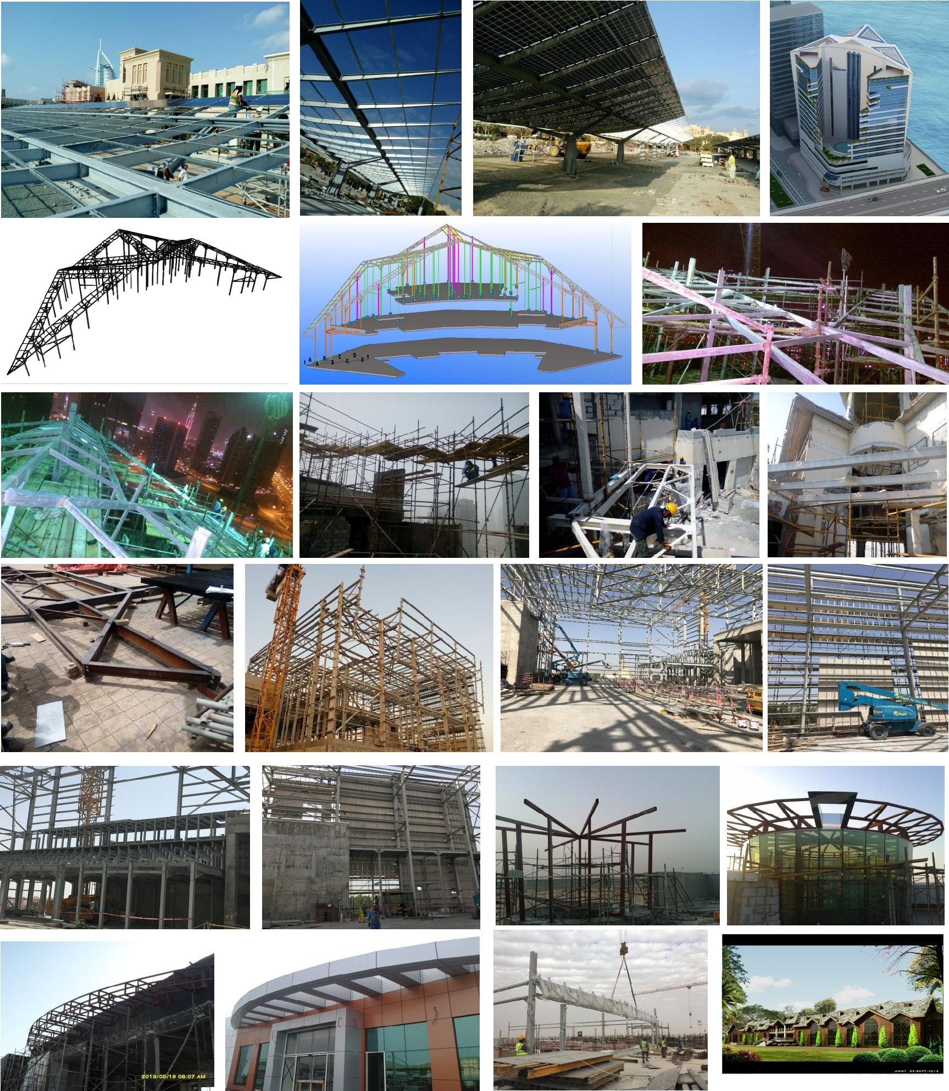

Page 6 of 6


