CV NO. 2009064

MUHSIN. P.P

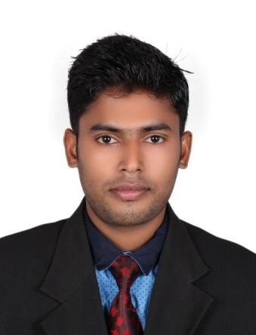

Career Objective

To build a challenging career with a reputed company and to serve the company with extreme dedication, put forth my knowledge for the benefit of the organization and be a dominant part of the company. An organized, bright and confident college leaver who is able to work closely with various stakeholders to ensure a timely and efficient recruitment and marketing process in any Administration or Sales department.

Summary

- Talented and energetic graduate with skills in administration.
- Well organized, punctual and efficient in the entrusted duties.
- Quick learner and hard worker.
- Excellent communication and writing skills.
(First Class)

Professional Summary
(Distinction)

Company : Super Tyres - Kerala

Duration : November 2010 – December 2012.

Designation : Accountant

Key Attributes:

- Organize and maintain financial records
- Improve businesses efficiency where money is concerned
- Inspect account books and accounting systems to keep up to date
- Suggest ways to reduce costs ,enhance revenues and improve profits
- Examine statements to ensure accuracy

Duration : May 2013 – October 2016.

Designation : Administrative Executive

Key Attributes:

- Payroll calculation of all staffs.

- Coordinate with HR Department for all HR related aspects.

- Entering and updating student’s information into databases.

- Preparing Certificates for House Surgeons.

- All office procurement in charge.

- Preparing the Admission procedures for the new academic year.

- Preparing the Inspection Works of KUHS University & Medical Council of India

- Handling entire daily activities of the office.

- Maintaining the office supplies.

- Issuing employee change letters (promotions, transfer, salary change etc.)
- Preparing of Certificates on request to employees.
- Analyzing and collecting the student’s documents.

- Respond to department telephones

- Editing documents and presentations.

- Preparation of University Examination.

- To send all students details to KUHS University & Medical Council of India every academic year.

Professional Summary

Company : TBG Hyundai (India) Ltd. Duration : January 2010 - October 2010. Designation : Sales Executive

Academic Qualification
(Final Year)

B a c h e l o r of Business Administration 2007 - 2010
(around 70%)

University of Calicut, Kerala - India

Additional Qualification

- Completed a course in “Maintenance of electrical & Home appliances” through the scheme of community development, for duration of three months in Government Polytechnic College, Kerala.
- Completed a course in “Diploma in Computerized Financial Accounting” during a period of three months in Institute of Information Technology, India.

- Completed a course in “Windows, MS Word, MS Excel, MS Power Point, Internet” during a period of two months in Institute of Information Technology, India.

Technical & Software Skills

- M i c r o s o f t office, Photoshop, OS – Win 98 -10, online skills.

Strength

- Able to work in a busy and varied role that requires good attention to detail.

- Accurate, timely, confidential and efficient record-keeping.

- Keeping abreast of changes in administrative policies and Procedures.

Languages Known

English : Write, Read, Speak Hindi : Write, Read,
Malayalam : Write, Read, Speak Arabic : Write, Read

Personal Details

Name: Muhsin. PP
Date of Birth: 01/01/1990
Marital Status: Single

Nationality: Indian

Visa Status: Visit Visa (Expire on 21st Feb. 2017)

References – Will be furnished upon request

MUHSIN. P.P – CV No 2009064
Whatsapp +971504753686
To interview this candidate, please send your company name, vacancy, and salary offered details along with this or other CV Reference Numbers that you may have short listed from http://www.gulfjobseeker.com/employer/cvdatabasepaid.php
addressing to HR Consultant on email: cvcontacts@gulfjobseekers.com
We will contact the candidate first to ensure their availability for your job
and send you the quotation for our HR Consulting Fees.

