SARITHA V.M – CV No 2009154

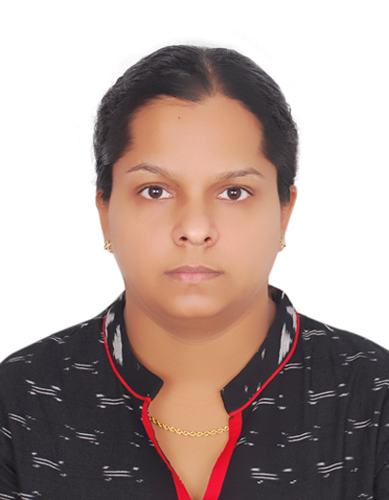

.

OBJECTIVE

Being a qualified Nurse with over 10 years of experience as well as having excellent inter-personal and communication skills, I wish to join in a well Organization where I can utilize my knowledge and experience which will certainly benefit the organization I work for.

PROFESSIONAL COURSE
- Passed (HAAD) Examination on December 2008, from Abu Dhabi, United Arab Emirates.(Licence no:GN916)
- Passed Diploma in General Nursing & Midwifery Diploma with Distinction from Government School of Nursing Alappuzha, Kerala, India on 2006

PROFESSIONAL EXPERIENCE

From 17.01.2009-
11.07.16 :
Designated as : Practical Nurse
Responsible for medical and surgical wards

From March 2006 to
January 2009 : Worked with Government Taluk Hospital Cherthala,Kerala,India
Designated as : Registered Nurse
Responsible for General Operation Theatre, Gynaec OT
Medical Surgical Wards

Duties and Responsibilities( Medical surgical wards):-

- Delivered complete range service for up to 8 medical – surgical patients including orthopedic, gastro intestinal, ophthalmology, urology, nephrology patients.
- Admitting patients transferred from ER, Conducting through physical assessments, obtaining and accurately documenting social, medical, surgical histories.
- Establishing trusting relationship with family members; providing education on plan of care, surgical, pressure ulcer, diabetic wounds.
- Facilitating patient recovery through collaboration with physicians, physiotherapist, respiratory therapist, dieticians.
- Providing a board range of general nursing care services in areas of vital signs, ECG, urinary catheterization and IV lines.
- Cultivated positive working relationship with peers and actively co-operated in emergency and life-threatening situations requiring rapid response.
- Commended clinical supervisor for exceptional performance and consistent adherence to institutional policies.
- Nursing care of patient with water seal chest drainage.

Duties and Responsibilities(Operation theatre):-

- Receiving patient, taking baseline vital signs.
- Explain procedure to the patient.
- Make sure that patient records are completed and consents signed.
- Transfer patient from stretcher to the operation table.
- Position thepatient for operation.
- Assist surgeon on gowning and gloving. Prepare instrument aseptically.
- Document all the events happen throughout the procedure.
- Counting all surgical instruments,needles,sponges used before and after the procedure.
- Transferring the patient and from OT to Recovery.
- Monitor vital signs.

ACADEMIC

- Passed (SSLC) Matriculation examination with 87.5% from Kerala, India.
- Passed Higher secondary Examination with 84% , from Board of Higher Secondary , Kerala , India

TRAINING AND SEMINARS ATTENDED

- BLS Health care provider course

- Preceptor Course
- IELTS PASSED
SKILLS

- Well knowledge in equipmenthandling such as ECG Machine, IV infusion Pumps, Suction Machine, Oxygen Tanks and computer literate.

PERSONAL DETAILS

Name : Saritha V.M
Date of Birth : 02-05-1985
Marital Status : Married
Nationality : Indian
Languages Known : Arabic, English & Hindi ,Malayalam
VISA STATUS :On Tourist Visa,Abudhabi
REFERENCES

Upon Request
SARITHA .V.M

SARITHA V.M – CV No 2009154
To interview this candidate, please send your company name, vacancy, and salary offered details along with this or other CV Reference Numbers that you may have short listed from http://www.gulfjobseeker.com/employer/cvdatabasepaid.php
addressing to HR Consultant on email: cvcontacts@gulfjobseekers.com
We will contact the candidate first to ensure their availability for your job
and send you the quotation for our HR Consulting Fees.

