Atique Ahmed Waseem Pasha – CV No 2009598

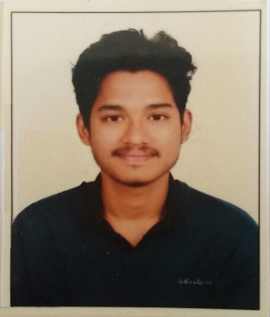
CURRICULUM VITAE

Personal Details

Nationality: Indian
Date of Birth: 4/12/1994
Languages known: English, Urdu and Hindi
Availability: Immediate

Career Objective

- To seek a respectful position in an organization, that provides numerous opportunities for continuous learning in a professional as well as a friendly atmosphere. Also, to seek a challenging position where my skills shall be utilized, while attaining organizations growth and finally to implement what I have learnt academically and professionally in order to attain higher level of knowledge in the fast pace world.

Education

- 12th grade CBSE from Indus World School, Sainikpuri, Hyderabad. (2013)

- Subjects covered were Accounts, Economics, Business Studies, Physical Education and English.

- Bachelor’s in Business Administration (BBA) from Osmania University, Hyderabad. (2016)

- The modules cover a range of areas such as Accounting, Finance, economics, Human
Resource, Marketing and Management skills.

Employment History

- Big Shot Motors Jan 2013 – March 2014

Customer service Representative [Customer service]
Job Profile:

- To ensure prompt and courteous handling of all enquiries from customers.
- Customer service, sales skills, patience and the ability to gain the confidence of clients by pitching in a few installment schemes by which the client could buy the vehicle within his level of satisfaction, which in turn would be my responsibility to reach out on a delayed payment through phone calls and even personalized visits so that the payment could be made in the given period of time.

- Tech Mahindra May 2014 - Feb 2015

Customer service and Technical support representative [Verizon telecom]
Job Profile:

- Handling the customer’s queries and assisting them in a best possible way.
- Assisting customers with issues related to their internet connection and problems related to their computers.
- Customer service,technical skills, sales skills and the ability to gain trust of our customers to help them and provide solutions in the best possible way.

- Nov 2015 – Aug 2016

ITES support and customer service representative [Microsoft Corp.]
Job Profile:

- Assisting in the maintenance of Microsoft Flagship stores in USA. Making sure that the customers at our stores do not face any inconvenience in their experience.
- Handling issues related to employee workstations.
- Providing solutions on fixing Microsoft office related applications.
- Backup Team Lead.
- creating presentations and excel sheets for the operations manager to provide statistics of the targets achieved in every month by the entire team.

Skills

- Possess excellent computer related knowledge with proficiency in MS. Office Applications.
- Good communication skills.
- Preparation of manual vouchers such as Cash Vouchers, Bank Vouchers, Sales Vouchers.

Reference

- Available Upon request.

Declaration
I hereby declare that the information furnished above is true to the best of my knowledge.
Regards,
Atique Ahmed.

Atique Ahmed Waseem Pasha – CV No 2009598
To interview this candidate, please send your company name, vacancy, and salary offered details along with this or other CV Reference Numbers that you may have short listed from http://www.gulfjobseeker.com/employer/cvdatabasepaid.php
addressing to HR Consultant on email: cvcontacts@gulfjobseekers.com
We will contact the candidate first to ensure their availability for your job
and send you the quotation for our HR Consulting Fees.

