SYED MUHAMMAD MOHAIB – CV No 2009952
To interview this candidate, please send your company name, vacancy, and salary offered details along with this or other CV Reference Numbers that you may have short listed from http://www.gulfjobseeker.com/employer/cvdatabasepaid.php
addressing to HR Consultant on email: cvcontacts@gulfjobseekers.com
We will contact the candidate first to ensure their availability for your job
and send you the quotation for our HR Consulting Fees.

SYED MUHAMMAD MOHAIB
ACCOUNTS & AUDIT PROFESSIONAL

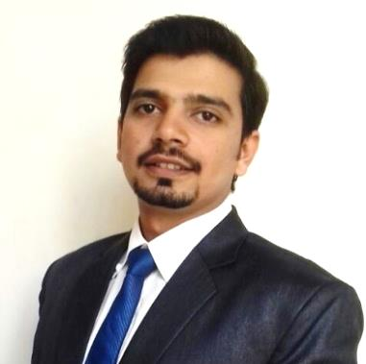

 |  |  | PERSONAL PROFILE |  |  |  |  | PROFESSIONAL CERTIFICATIONS
I am self-disciplined and ambitious individual, passionate about developing my career in the field of Accounts and Audit. Possessing more than Five years of experience of working with multiple companies of different industries. I have the ability to develop an efficient approach to any task that I undertake with an aim to maximize organization profitability. |  |  |  |  |  |  | - ACCA  ACCA UK (Final paper result awaiting)  - Advance Excel & Financial Modeling  Abeel’s School Of Accountancy (2014)  - Advance Diploma in Accounting & Business  ACCA Glasgow UK (2013)
 |  |  | FINANCIAL SKILLS |  |  |  |  | ACADEMIC QUALIFICATION
- Financial Statements |  |  |  |  |  |  | - Master in Economic  University of Karachi (Qualified in 2016)  - Bachelor in Commerce  University of Karachi (Qualified in 2009)
- Financial Modeling |  |  |  |  | 
- Financial Analysis |  |  |  |  | 
- Forecast & Budgeting |  |  |  |  | 
- MIS Reporting Skills |  |  |  |  | 
- Assets Management |  |  |  |  |  |  |  | PROFESSIONAL EXPERIENCE
- Payroll Management |  |  |  |  | 
- Payables Management |  |  |  |  |  |  | - MANAGER ACCOUNTS  Feb 2014 – Dec 2016 (3 Years Approx.)  - Prepare monthly & annually financial statements.  - Prepare various financial analyses and give report on financial performance & findings to management.  - Correspondence with bank on LC opening/retirement.  - Supervise monthly closing of books of accounts.  - SENIOR AUDITOR  S.M. SUHAIL & CO. (CHARTERED ACCOUNTANTS)  Jul 2012 – Jan 2014 (1.5 Years)  - Perform financial audits as per ISA.  - Prepare audit plan in collaboration with audit team.  - Perform and supervise other assignments.  - Prepare statutory financial accounts as per IFRS.  - ACCOUNTS EXECUTIVE  Y.C TRAVELS  Jan 2011 – Jun 2012 (1.5 Years)  - Maintain accounts payables.  - Maintain accounts receivables.  - Book keeping of daily transactions.
- Receivables Management |  |  |  |  | 
- Bank Reconciliation |  |  |  |  | 
- Merger Accounting |  |  |  |  | 
 |  |  | IT SKILLS
- Microsoft Office |  |  |  |  | 
- Quick Books, Tally ERP |  |  |  |  | 
- SAP & Oracle - ERP |  |  |  |  | 
 |  | PERSONAL SKILLS
- Communication |  |  |  |  | 
- Tackle Time Pressure |  |  |  |  | 
- Multi Task Handling |  |  |  |  | 
- Leading Team |  |  |  |  | 
 | PERSONAL INFORMATION
- Nationality |  |  |  | Pakistani
- Religion |  |  |  | Islam
- Father’s Name |  |  |  | Syed Abdul Kaleem
- Date of Birth |  |  |  | 16th June 1988
- Martial Status |  |  |  | Single
SYED MUHAMMAD MOHAIB – CV No 2009952
To interview this candidate, please send your company name, vacancy, and salary offered details along with this or other CV Reference Numbers that you may have short listed from http://www.gulfjobseeker.com/employer/cvdatabasepaid.php
addressing to HR Consultant on email: cvcontacts@gulfjobseekers.com
We will contact the candidate first to ensure their availability for your job
and send you the quotation for our HR Consulting Fees.

