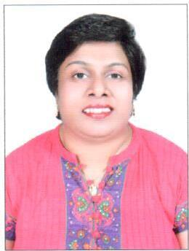
Beveleen
Beveleen.335050@2freemail.com

_____________________________

Objective:
Being physically challenged person I would like to build my career with an organization that will believe in my ability to serve to the best as well as to develop and grow and be an asset to the organization.

Work Experience:

- Expat Properties, Dubai: 2011- Present
Position: Receptionist/Tele sales executive/Document Controller.
- Worked as Telesales Executive fixing appointments for the sales Executives for Media division.
- Coordinating with sales executives and handling the division.
- Dealing with customers for document dispatch and collection of documents and coordinating with the India Head office and updating with the excel sheets.
- Handling the Reception.
- Meeting and greeting clients.
- Arranging couriers.
- Keeping the reception area tidy.
- Answering and forwarding phone calls.
- Screening phone calls.
- Sorting and distributing post.

- New Oasis Advertising LLC: 2008-2009
Position: Tele marketing executive.
- Fixing appointments for sales executive for Advertise Requirements and bringing business to the company.

- Maintec Technologies Pvt Ltd (IT Company)
Position: Front office Executive 2004-2006
- Customer Service.
- Keep record of Staff on Time attendance.
- Data Entry.
- Collect Daily Business News from Website edit it and send to the US Clients on line.

Education:
- Bachelor of Arts 2000- Completed Degree in Bachelor of Arts, Majoring in English at Roshni Nilaya, Mangalore - India.

Computer Knowledge:
MS office (Word Excel, Power point) at Marian Institute of Computer Science, Mangalore, India.

Hobbies:
- Reading Novels
- Listening to Music

Personal Details:
- Place of Birth: Dubai
- Date of Birth: 4th June 1974
- Visa Status: Residence Visa
- Religion: Christian
- Marital Status: Single

References:
Available upon request.

