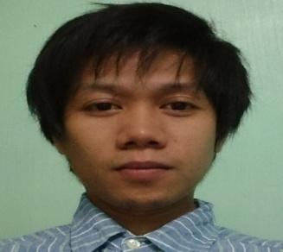
Mark
Mark.335060@2freemail.com

Objectives:
To work hard with full dedications for the achievement of company needs under satisfying job contact, hence enhancing my skill and knowledge as well as eager to learn new things.

Educational Background:
Tertiary (College Graduate) Assoc. Computer Technology and Networking
BestLink College of the Philippines
1044 Brgy. Sta. Monica Quirino Hi-way
Novaliches Quezon City, Metro Manila

Personal Data
Age: 31 yrs. Old
Birthday: May 30, 1985
Gender: Male
Nationality: Filipino
Religion: Roman Catholic
Height: 5’6”
Weight: 110 Lbs.

Skills:, PC and Laptop Troubleshooting, Software & Operating System Installation,
Computer Upgrading, Computer Networking and other Computer Peripherals.

Training & Seminars with Certificate: Adobe Photoshop & AutoCAD2015

On Job Training
(March to April 2005) Interpeople Corp.
Gen.Mngr Jepty Robantes
#168 Mindanao ave. Bahay Toro Q.C

Working Experience
(May 2005-September 2006) Mngr. Ms. Michelle Almonte
Computer Technician/Salesman Mil’s Computer Center (MCC)
Fairview avenue Q.C Metro Manila

(October 2006-December 2008) Mngr. Mrs Jennyfe Encabo
Computer Head Technician/Salesman Pcplus Computer Center
Cubao Branch Q.C Metro Manila

(February 1,2010 - July 22,2014) Co. Owner Mr. Ibrahim Yehia (SADETRA)
Technical Maintenance & Computer Operator Military Target Shooting Range (Saudi Arabia)
Ass.Purchasing Officer & Document Controller Saudi Development & Const. Co.(Main Office)
(RIYADH SAUDI ARABIA, KSA)

