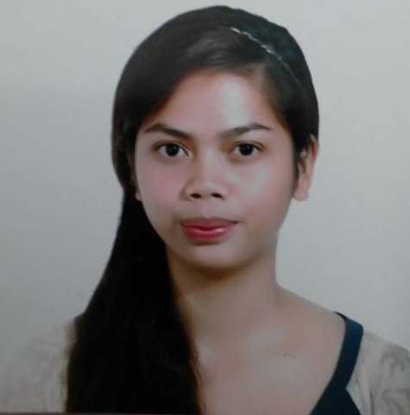
Jovelle
Jovelle.335063@2freemail.com

- Objective :

Obtain a position in an environment where there is a need for a variety of office management tasks such as computer knowledge, database program use, and organizational abilities to be utilized.

- Skills and Personal Strength:

- Organized and Accurate
- Flexible and Adaptable to changes
- Well Determined and Motivated
- Has excellent knowledge in MS Word, Excel, Powerpoint and Publisher
- Skilled at balancing multiple tasks
- Outstanding in public relations
- Excellent Verbal and Written Communication Skills

- Work Experience:

Compensation and Benefits Supervisor (October 2015 – November 2016)
Marcventures Mining and Dev't. Corp.
Administration Department - Compensation and Benefits Section

- Maintains and updates employee records by collecting, calculating and encoding data.
- Collects timesheet submitted then ensures compliance with existing policies and procedures.
- Ensures payslips are submitted and post changes in tax status and other regulatory requirements by the government.
- Retains excellent knowledge of the payroll to help answer employee queries.
- Creates memorandums and letter when in instructed.
- Performs other duties and responsibility that may be assigned as necessary.

Executive Secretary ( July 2013 - October 2015)
Marcventures Mining and Dev't. Corp.
Mine Operation Department

- Maintains department schedule by maintaining calendars for department personnel, arrange meetings, conferences and travel.
- Provide administrative and clerical support to department or individuals as per supervisor’s statements.
- Creates memorandums and letters as per advice by supervisors such as incident reports.
- Organizes work by reading and routing correspondence, collecting information and initiating telecommunications.

Receptionist / Secretary (March 2013-July 2013)
Oasis BeachView Resort and Hotel

- Receive guests to the hotel by greeting them warmly, and attending to their inquiries and also answer inquirers over the hotel.
- Inform guests of the services and accommodation rates in the hotel, make reservations for the guests according to their needs.
- Maintain orderliness at the front desk by arranging documents accordingly and keeping the front desk area clean.
- Attend to all routs of room bookings, such as online, phone and in person, to ensure that reservations are not left hanging but attended to promptly to keep the hotel business running.

- Educational Attainment:

- Bachelor of Science in Computer Science (2009-2013)
Saint Michael College - Cantilan Campus
Din’s Lister
- Cantilan National High School (2005-2009)
Cantilan, Surigao del Sur
Honor Student

- Trainings and Seminars:

- Effective Human Resources (HR) Systems and Practices
BTC GM and Managing Consultancy

- TESDA Computer Hardware Servicing NC II
- Accounting for Non-Accountants
- Civil Service Sub-Professional Certificate
- Work Values Orientation
Re-visiting values at work

- Personal Information:

Citizenship: Filipino
Age: 23
Date of Birth: April 12, 1993
Civil Status: Single
Height: 5'3''
Weight: 55 kls.
Religion: Catholic

I hereby certify to the best of my knowledge that the above information contained in this resume is true and correct.

