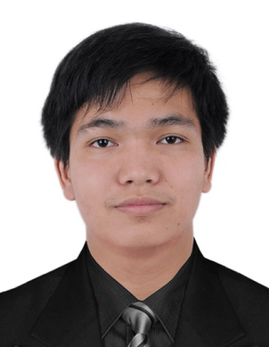
ERIC

ERIC.335072@2freemail.com

EDUCATIONAL ATTAINMENT

Tertiary : Bachelor of Science Information Technology
Quezon City Polytechnic University
San Bartolome, Novaliches Quezon City
2008-2012

Secondary : Villazar National High School
North Villazar Sipocot Camarines Sur
Year Graduated: 2008

Primary : North Villazar Elementary School
North Villazar Sipocot Camarines Sur
Year Graduated: 2004

WORK EXPERIENCES

NATIONAL MEAT INSPECTION SERVICES
IT Assistant
Visayas ave Quezon City
On-the-Job-Training (OJT)

- To diagnose and resolve software and hardware incident.
- To accurately record, update documents.
- To install and configure new equipment.
- To resolve incidents and upgrade different types of hardware and software.

Philippine Long Distance Telecommunication (PLDT)
Operations Database Support Assistant (ODSA)
PLDT Diliman Central Office
July 2012 – December 2016

CLARITY INTERNATIONAL SYSTEM

- Check and verify all the address or location of the subscriber
- Change node/port of NGN and FTTH
- Create a Circuit Using Clarity(Design Circuit)
- Facility Assignment
- CID Creation / Creating of new address in the system
- Service Order Processing
- PPGIS / Locating facility via satellite system

SKILLS

Knowledgeable in:

- Microsoft Word, PowerPoint, Excel, Outlook
- Windows XP,7 and 8 Operating System
- Html/vb.net and PHP
- Computer Literate
- Installation of Applications
- Networking
- Telephone and Internet installation
- Troubleshooting
- Can set up and configures desktop computers, peripherals and accounts
- Troubleshoots, diagnoses problems, implements corrective action procedures within prescribed guidelines and/or escalates to other technical resources as appropriate
- Transfers computer files between platforms

PERSONAL

Date of Birth : October 9, 1991
Place of Birth : Sipocot Camarines Sur
Age : 25 year old
Civil Status : Single
Religion : Born Again Christian

