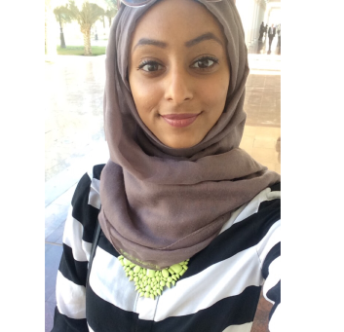
Nadia
Nadia.335092@2freemail.com

Objective
To enhance my skills by working intensely in an acknowledge laboratories in a highly motivating and challenging environment that provides the best opportunities to achieve the institution's goal, in addition to my personal goals.

Education:
2016
- Graduated from college of Science, department of Applied Biology (Biotechnology) at The University of Sharjah with a GPA of 3.77.
2012
- Obtained an IELTS certificate with a 6.5 overall score.
2007 - 2012
- Went to Rosary Sisters high school and graduated with a 95.5 score.
2000 – 2007
- Went primary and middle school at Al Jazeera private school.

Work experience

- Currently enrolled in an internship program at Biotechnology Center at University of Khalifa, in which I was responsible for instructing two students the DNA extraction method from Saliva. ECG data analysis and controlling DNA samples also took place. Working on diabetes implications on cardiovascular diseases project with Dr.Habiba Al Safar. (18th September – ongoing)
- Had an internship at Dubai Blood Donation Center (DBDC) in the summer of 2015 for six weeks (June/July).

- Participated in the organization of the Second International Conference on Arab's and Muslim's History of Sciences that took place at The University of Sharjah. (December 2014).
- Worked as an organizer in Formula 1 at Yas Island for Wow Events (November 2014)
Honors & Awards
- Obtained a certificate for participating in the 3rd Biotechnology student's exhibition.
- Obtained a certificate for volunteering in the "The World Wetlands Day - 2016" for government of Dubai.
Personal attribute
- Ability to work well under pressure and to deadlines.
- Excellent communication skills.
- Able to work as a part of a team or alone.
Language skills
- Fluent in writing and speaking Arabic.
- Excellent in writing and speaking English.
Computer skills
- Excellent in Microsoft word.
- Excellent in LabChart.
- Good in using Microsoft Excel.
- Good in using IBM SPSS Statistics 21 program.
- Good in using the CodeBlocks (C++)

Presentation (oral & poster)
- Green Synthesis of Gold Nanoparticles using Native Plants of UAE. University of Sharjah, June 2016.
- Pre-implantation genetic diagnosis (PGD). University of Sharjah on 17th December, 2014.
- Regenerative Medicine. University of Sharjah on 18th December, 2013.
Fields of interest
- Forensic sciences
- Gene therapy
- Stem cells
- Medicine Biotechnology
- Molecular and cellular Biology
- Environmental Biotechnology

