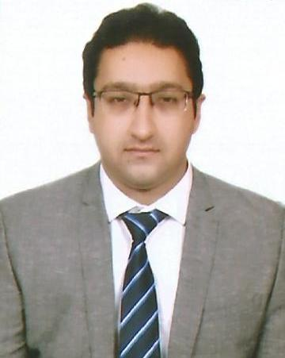
Samir
Samir.335106@2freemail.com

PERSONAL
INFORMATION Marital status: Married
Nationality: Indian
D.O.B: 23rd March 1985
Visa Status: Visit Visa
Place of Birth: Lucknow, India

CAREER OBJECTIVE
PROFESSIONAL |  | High energy management professional with an experience of 5 years’ in the field of Administration. A Public Relations Specialist with proven ability to achieve predetermined targets. Looking for a suitable profile in a reputed organization wherein I can grow with the organization.
EXPERIENCE  October 2016 to  January 2016 |  | Pearson BTEC - Programme  “Student support and Mentoring”  - Maintaining a tracker for students work.  - Evaluating students work helping them in achieving the criteria.  - Conduct market research and needs assessment & develop and maintain professional contacts.  - Giving specialist administrative support and advice or guidance to students and dealing with complaints and enquiries.  - Meeting face-to-face with students to give guidance.  - Answering and dealing with telephone enquiries.  - Helped to organize examinations and assessments.
April 2016 to |  | DUNIA FINANCE
Sep 2016 |  | “Relationship Officer”
 | ▪ | Identifying and targeting potential clients for business development.
 | ▪ | Assisting clients for short and long term funding requirements of business and personal use.
 | ▪ | Communicating clients regarding their queries and providing best possible solutions.
 | ▪ | Taking active part in team meetings and suggesting new ways of working to generate more business
 | ▪ | Analyzing and designing the best financial package best suited to the needs of the clients.
 | ▪ | Checking the loan eligibility of the customers by using my financial acumen and checking his credit history to identify and prevent financial fraud.
January 2012 to |  | LUCKNAVI HANDICRAFTS
January 2016 |  | “Store Manager”
 | ▪ | Providing excellent shopping environment to customers and generating maximum results.
 | ▪ | Responsible for planning and management of store functions.  Keeping the store organized and clean all the time.
 | ▪ | Developing friendly relations with customers to strengthen sales.
 | ▪ | Suggesting products to customers matching their personality.
 | ▪ | Responsible for hiring and training individuals.
 | ▪ | Effectively manage and arrange all activities and programs in store.
 | ▪ | Handling cash, inventory and maintaining accounts of the store using the latest POS system and computerized operating systems.

July 2010 to YORK INN HOTEL
Dec 2012 “Guest Relations Manager”

- To attend guests in friendly and professional manner to achieve guest delight.
- Maintaining list of all VIP and VVIP guests visiting the hotels and looking after their need within the hotel guidelines
- Manage and maintain record of all guests, remarks and complaints.
- Maintain amiable and effective relations with other hotel departments and staff.
- Taking customers feedbacks regarding the services and seek opportunity to up-selling to create brand image and generate more revenue.
- Keep full knowledge of the services provided by the Hotel and seek opportunity to up-selling to guest to generate more revenue per guest
- Actively attending all meetings, trainings and development programme to keep myself up to date.
- Managing events such as meetings, conferences, parties. Including coordination with multiple stakeholders.

Aug 2009 to BAJAJ PROBIKING
“Showroom Manager”
June 2010

EDUCATION:
- POSTGRADUATE DIPLOMA Accman College of Management
In Retail Management Noida, India

- BACHELORS Lucknow University

In Tourism Administration Noida, India

INTERMEDIATE La- Marteniere College
Lucknow, India

INTERNSHIP:
6 MONTHS INTERNSHIP Spencer’s Hyper Retail Store
Lucknow, India

SKILLS:
- Good Communication skills
- Strong IT and analytical skills
- Leadership Qualities
- Organization & Time management skills
- Keen to face Challenges
- Customer relationship building skills
- Target Oriented

DECLARATION

I hereby declared that all the information stated above is true to the best of my knowledge.

