MUHAMMED

MUHAMMED.335115@2freemail.com
Graphic Designer

“

BIOGRAPHY | LANGUAGES
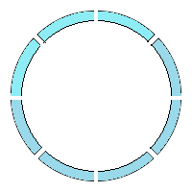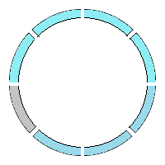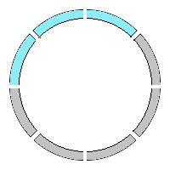  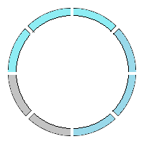  I am a young and imaginative graphic designer, with experience in production, design. I received my diploma from Tech River Institution in 2010, with a major in Advertising and minor in Web Designing. My Hobbies focus on aesthetics and their impact on society and need to inject this energy and flow of ideas where I can contribute my skills to a professional company.  I am currently seeking full-time employment with a company or studio that is creatively challenging and can bring a long committed relationship. | ARABIC  Mid-Level  ENGLISH  Advanced Level  MALAYALAM  Mother Language  HINDI  Advanced Level
WORKING EXPERIENCE | DESIGNS SKILLS
1 year Experience in Graphic Designer at  “SMART PRINT” Smart City, Thokkottu, Mangalore.  2 years’ Experience in Graphic Designer  Teaching at “SPOORTHI STUDY CIRCLE” University  Road,Mangalore – 575017.  3 years’ Experience in Graphic Designer at  “TECH RIVER INSTITUTION” Madani PU College Road, Thokkottu, Mangalore – 575020.  1 year Experience in Designer at “ACCESS  DESIGN SOLUTION PVT. LTD” Mangalore – 575001. | Corel Draw  Adobe Photoshop  Adobe InDesign  Adobe Flash  Drawing  Page Maker  MS Office
EDUCATION | PERSONAL SKILLS
Diploma in Graphic designing.  DTP (Corel Draw, Photo Shop, Page Maker)  MS Office  DCA (Diploma in Computer Application)  PGDCA (Post Graduation Diploma In  Computer Application) | Creativity  Cooperation  Communication  Organizing  Professional in Teaching MS office, Photoshop,  Corel Draw, Page Maker.
COMPUTER KNOWLEDGE | INFORMATION
Basic Computer (Word, Excel, Power Point)  DTP (Corel Draw, Photo Shop, Page Maker)  MS Office  DCA (Diploma in Computer Application)  PGDCA (Post Graduation Diploma In  Computer Application) | Date of Birth: 11 January 1992  Place of Birth: Mangalore, Karnataka  Marital Status: Single  Nationality: Indian
EXTRA CURRICULAR ACTIVITIES | HOBBIES & INTERESTS
- Undergone vocational training Programmed  in ITES (Information Technology Enabled Services) at Dr.Reddy’s Foundation, Mangalore.  - Participated in various “NSS STATE LEVEL CAMP”  in Sulya. During the year 2010.  - Undergone course of training in SDP on CNC  Programming & Machining Conducted by the Br.  MSME-DI Mangalore. | Creative Design Social Networking  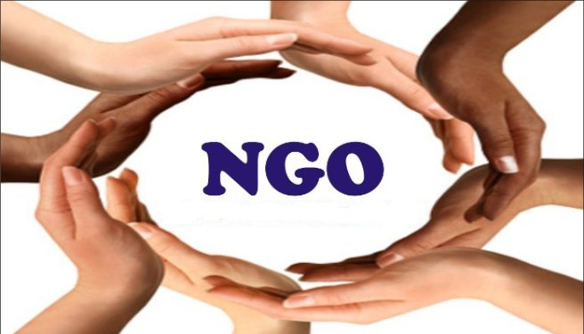  Teaching Orphanage Service

