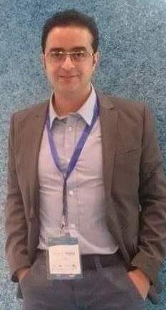
Fady
Fady.335142@2freemail.com

FEC Manager

An expert and professional Theme park manager with extensive experience in administration, and secretarial roles, currently seeking a new position as an Executive, FEC supervisory role. A highly organized and efficient individual, willing to move for a new challenge where I can apply what I have skills and experience to add more values to my new career.

Key Skills

- 40 words per minute typing (English and Arabic ) ,Translation ,Reporting .
- Proficiency of Microsoft Office, including , Excel, Word and PowerPoint
- Excellent communication skills, both written and verbal ( English +Arabic )
- Team work and coaching skills
- Safety and health guidelines in FEC certified
- Customer services skills
- Fully qualified first-aid ,safety and quality application in Theme parks .
- Well versed in Intercard back office manager ( Theme Park software )

Employment History

FEC Manager, Othaim for Leisure and Tourism , Saudi Arabia
(Jan 2016 – Sep 2016 )
Responsibilities:

- Devise and Implemented SOP for each department in the park and provide training for staff accordingly
- Oversee operations in the park and monitor opening and closing
- Helped provide a safer workplace by cataloguing and dispatching health and safety information and posters for the whole company
- Diary management, typing correspondence and documents, creating presentations and creating meeting minutes
- Ensure park revenues and target are being followed and maximize footfall

FEC Manager , Hokair Group for Tourism , Saudi Arabia
(April 2011 – Jan 2016)

Responsibilities:

- Handle staff in the park including but not limited ( Training ,appraisal , bonuses ,leaves ,salaries etc )
- Managing park operations ( opening ,closing ,reporting )
- Organising stationery orders and liaising with suppliers to meet business requests
- Handle the park cash ( petty cash ,cash float ,budget control )
- Also assumed the role of fire/health and safety officer for the entire park
- Leasing management

Guest Services Supervisor (Telephone Department ), Pre opening Angsana Hotel Team , Dubai ,UAE
(2008 – 2009)

Responsibilities:

- Supervise a team of CSR and monitor the calls
- Answering incoming calls from the VIP Guests and handle issues
- Organise staff roster and shifts
- Orientation for new staff and Training
- Liaise with other department to ensure smooth running of Hotel operations

CSR , Orange Telecom Group , Amman , Jordan
(2006 – 2008)

Responsibilities:

- Answer all incoming and outgoing calls from customers
- Promote GSM products and services including Internet and Landline
- Uses high quality customer services and keep service level excellent
- Call back customers to follow up

Education

Isra Private University
(October 2002 – March 2005)

- Bachelor Degree In Business Administration

Hobbies & Interests

I am kind of person who like biking, swimming, table tennis ,I also enjoy music .

References

References are available upon request.

