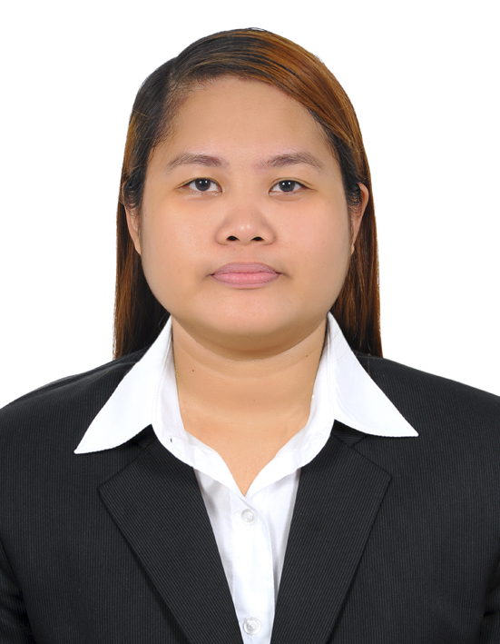

JENNIFER
JENNIFER.335149@2freemail.com

I have over 6 years experience, with expertise in handling administrative responsibilities and providing customer service support. I am a well-qualified, trained and experienced professional.

I am an independent worker with the ability to perform to a high standard in a high pressure and demanding work environment, and to effectively prioritise and manage my job responsibilities.

Key Skills: Effective Communication and Listening skills, Computer and Presentation Skills, Client Relationships, Customer Satisfaction

WORK EXPERIENCE

Publishing Consultant, Xlibris Publishing – Author Solutions Inc. Cebu Philippines- June 2016 – December 2016

- Bringing in Sales in the company by calling and helping authors realize their dreams.
- Providing adequate and relevant details prior to closing the sale to avoid future refunds.
- Keeping in touch to the clients to ensure that the interest is maintained so they can upgrade their project by continuously investing through the post-publication services.
- Address client’s concern while the project is in progress to provide satisfaction so they will continue to invest their future projects in the company.

Email Specialist, Beach Camera,com and Buydig.com- Focusinc Group Corporation, Bacolod, Philippines – August 2015 – June 2016

- Validating customer’s data via order number entry.
- Responding to customer’s concern through email.
- Contacting the courier of shipments for missing orders to provide an updated and accurate tracking information to customers.
- Processing replacements of orders and refunds as per customer’s request if necessary as supported by the courier’s report.

Sales & Customer Service Representative , Time Warner Cable- Teleperformance Philippines, Bacolod City - July 22, 2014- May 2015

- Taking calls from customers who seek help in technical troubleshooting and billing concerns.
- Updating customer’s data by placing notes on the customer’s portal on the point of contact.
- Testing the results to make sure the issue is resolved before the customer disconnects the call.
- Explains the billing cycle thoroughly and process refund requests when necessary.
- Provides estimated time frame and setting proper expectations to avoid escalations.
- Up sell services that may help the customer save more money and for the company to gain revenue/sales at the same time.

Admin. Trainee - Bacolod City Water District, Admin - December 2013 - March 2014

- Keeping track of the vehicle and employee names that arrives and leaves the premises for easy inventory of the engineering department.
- Archiving important reports pertaining to employees and resources within the company.
- Helps in planning activities that will boost the relationship of employees and the Administrative department.

Customer Service Associate, Amazon.co.uk - Convergys Philippines Corporation - November 2012 - December 2013

- Responding to customer’s concerns via Chat and Email.
- Ensuring professional communication by constructing effective emails and chat responses.
- Conducting thorough research and investigation before escalating concerns and resolving them the soonest possible time.
- Processing refund and replacement requests if necessary to ensure customer satisfaction all the time.

Technical Support Representative, Telstra – Teletech Bacolod – February 2010-May 2012

- Troubleshooting internet concerns over the phone.
- Ensure customer satisfaction by resolving the concern as soon as possible and by securing their accounts by asking relevant questions to prove their identity as account owners.

Student Assistant , Office of the Student Affairs, Silliman University -
Silliman University, Dumaguete City, Negros Oriental Philippines - November 2009- March 2010

- Keeping student files in archives and data entry of new student records for easy access of names all throughout the University.
- Reporting daily to the University Dean.
- Activation and validation of University Identification cards and car stickers for new students.

EDUCATIONAL BACKGROUND

BS Public Administration (Graduate) – 2011 - 2014
West Negros University, Bacolod City, Negros Occidental , Philippines

Bachelor of Science in Medical Technology – 2008 - 2010
AB Political Science, Silliman University – 2009 – 2010
Silliman University, Dumaguete City, Negros Oriental , Philippines

