FRANKLINE
FRANKLINE.335154@2freemail.com

Date of birth | : | May 19, 1973
Age | : | 43 years old
Marital Status | : | Married
Nationality | : | Filipino
Visa Status | : | eVisa valid until 14 March 2017
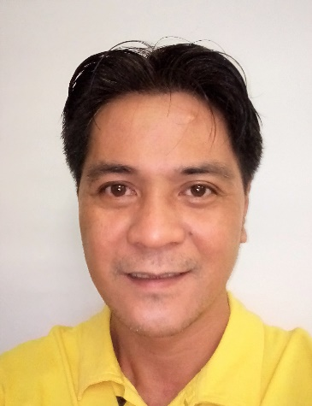

Career Objective
A challenging and rewarding position as I.T. TECHNICAL SUPPORT or any I.T. Position available.

Profile
Tech savvy and able to communicate well in both written and spoken English. Highly trainable and a fast learner. Able to handle problems and provide solutions in a timely manner.

Technical Skills

Software
Database Programming using Foxpro, Visual Basic Programming, Visual Basic for Application, C/Turbo C, C++, Microsoft Office Excel, Word, PowerPoint and Outlook

Hardware
PC Troubleshooting, PC Assembly, LAN Installation & Configuration, PC Parallel/Serial Port Interfacing, routers, switches, hubs, DSL modems

Environment
Microsoft Windows XP/2000/Vista/7/8/8.1/10

Educational Profile
TESDA COC1 Certified on Object Oriented Programming (2009)
Using Microsoft Visual Basic 6.0

Lyceum Of The Philippines, Intramuros, Manila (2002)
B.S. Computer Engineer Undergraduate

Canossa Academy, Calamba, Laguna (1990)
High School

Career History
COGNIZANT TECHNOLOGY SOLUTIONS INC.
Systems Executive
Building No. 10 Upper McKinley Road
McKinley Hill, Fort Bonifacio
Taguig City Philippines 1634
January 2015 to April 2016

- Troubleshooting and resolving computer issues over the phone or through email
- Routing/Escalating tickets to the correcting department in case the issues are not resolvable by the service desk department
- Monitor and follow up on escalated tickets to ensure that the issue is resolved
- Ensure that the user is satisfied with the resolution
- Educate the users about the cause of the issue and provide next steps

CONVERGYS formerly DATACOM CONNECT Philippines
Tier 2 Technical Support Representative
11th Floor, Commerce and Industry Plaza Campus Avenue Corner Park Avenue, McKinley Hill Fort Bonifacio, Taguig City 1634, Philippines
From October 2012 to January 2015

- Troubleshooting Microsoft Windows and Microsoft Office issues on End User computers over the phone and through email
- Resolve PC safety, Malware and PC health issues
- Follow up on resolve issues to ensure customer satisfaction before closing tickets
- Educate users to ensure that issues will not reoccur
- Scrub unresolved tickets and recommend solutions to ticket owners

ALORICA PHILIPPINES INC formerly ADVANCED CONTACT SOLUTIONS INC.
Technical Support Representative
ACS Plaza, Ground Floor, Senator Gil Puyat Avenue corner Tordesillas Street, Makati
From October 2010 up to June 2012

- Guide end users and technicians for initial setup of internet modems and/or routers
- Troubleshoot internet connectivity issues over the phone
- Accessing end user computers using a remote access tool and resolving software issues
- Create tickets and escalate tickets to onsite technicians for facility repairs when necessary
- Provide next steps, user training and educate users about the resolution provided
- Ensures customer satisfaction by the end of the call

NCO/RMH Teleservices Asia Pacific, Inc
Customer Service Representative
2nd Floor Blue Wave Blg. Mall Sumulong Hiway Cor. Gil Fernando Ave. Marikina City
From October 2009 to April 2010

- Provide technical support for mobile phone users
- Add calling and data features to network subscribers based on customer requests
- Assist dealers in activating mobile phone services to their customers
- Deactivate phone services based on dealers or customer requests
- Ensure customer satisfaction all throughout the phone call

WEST Contact Services Inc.
Technical Support Representative
24TH Floor Exportbank Plaza Chino Roces Ave. Corner Buendia Ave. Makati City
From May 2009 to July 2009

- Guide end users and technicians for initial setup of internet modems and/or routers
- Troubleshoot internet connectivity issues over the phone
- Accessing end user computers using a remote access tool and resolving software issues
- Create tickets and escalate tickets to onsite technicians for facility repairs when necessary
- Provide next steps, user training and educate users about the resolution provided
- Ensures customer satisfaction by the end of the call

ALORICA PHILIPPINES INC
Technical Support Representative
33rd Floor Wynsum Corporate Plaza, F. Ortigas Jr. Ave. Ortigas Center Pasig City
From July 2008 to February 2009

- Assist customer in setting up their newly purchased network device(/s)
- Troubleshoot connectivity issues
- Advise users to contact their Internet Provider in case their purchased device require additional configuration
- Ensure customer satisfaction all throughout the phone call and close tickets as resolved

GUARD-ALL ELECTRONIC Security System Inc.
Computer Programmer
Cattleya Bldg., 235 Salcedo St., Legaspi Village, Makati City
From September 2003 to February 2005

- Code programs to retrieve data from an access control system database
- Convert data from the access control system to a specified format required by clients
- Configure door access for employees
- Code programs to access and retrieve match codes of proximity cards
- Setup access control servers
- Install access control software
- Provide user training in using the access control software

