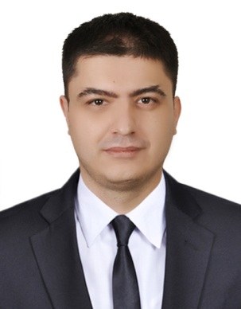
FARRUKH
Email: farrukh.335199@2freemail.com
Date of birth: 19/04/1989
Nationality: Uzbek
Burjuman, Dubai, UAE

OBJECTIVE To obtain a position in the industry which will enable me to use my strong organizational
skills, educational background, previous experience, extensive knowledge and ability to collaborate with people.

EDUCATION Bachelor of Business Administration Degree in Business Studies, Cardiff Metropolitan University 2012-2016 Malaysia and more than 1.5 years of experience in sales & marketing field

EXPERIENCE –Malaysia. Dec 2015- Apr 2016
Industrial Trainee
- Worked in Energy Management Department at Sales Division
- Assisted Sales Team on quotation and daily sales activities
- Liaised with Commercial Team on managing sales documents (purchase order, offer letter etc.)
- Liaised with BSS Team on order process (ordering, delivery, invoicing to customers etc.)

Sales Assistant
“DIESEL – BERJAYA TIMES SQUARE, Kuala Lumpur, MY 2014Mar–2015 Oct

- Greeted every customer with a smile, friendly conversation, and offered of assistance to enhance customer experience and buying opportunities.
- Assisted customers with trying on items, finding appropriate sizes, and completing purchases
- Suggested accessories and matching clothes to increase purchases.
- Inquired about buying experience, item preferences and future purchases
- Handled customer complaints professionally, in line with the company policies
- Signed customers up for marketing lists and informed of upcoming promotions or customer events.
- Updated customers’ database accurately by entering their details on the POS system

Sales Associate
TOMMY HILFIGER”” – PAVILION Mall, Kuala Lumpur, MY 2012Oct–2014 Feb
- Presented flattering items based on customer preferences.
- Answered questions regarding items and promotions.
- Used consultative sales approach to successfully build relationships with high‐end buyers.
- Monitored trends and provided information to customers to maximize purchases.
- Used consultative sales approach to successfully build relationships with high‐end buyers.
- Checked stock levels daily and sent stock request to distribution center to maintain necessary stock level.

Languages
Mother tongue: Uzbek
 | Listening | Reading | Writing | Speaking
English | Fluent | Fluent | Fluent | Fluent
Russian Arabic | Fluent | Fluent | Fluent | Fluent
Arabic | Basic | Basic | Good | Basic

COMPUTER
SKILLS Familiar with MS Word, Excel Adobe Photoshop, Sony Vegas Pro

PERSONAL ► Highly motivated to achieve work objectives
► Ability to work well under stress
► Dedicated, focused, and diligent

INTERESTS: Languages, Golf, and Family activities

