CURRICULUM VITAE
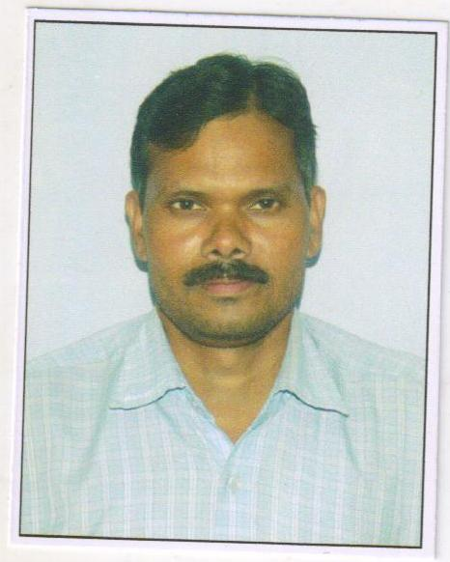

Rajesh
Rajesh.335213@2freemail.com

D.O.B. :- 15-02-1981

Marital Status: - Married

CAREER OBJECTIVE

►Seeking a challenging & responsible position that will provide a well- rounded exposure to develop my business skills as well as improve my inter personal abilities and invest all my professional expertise, qualification, valuable experience to the optimum level to facilitate continued career growth.

Personal Skills
►Comprehensive problem solving ability and deal with people diplomatically, willingness to learn, team facilitator.

Summary of Qualification:

►Matric from U.P. BOARD ALLAHABAD
►10+2 from U.P. BOARD ALLAHABAD

►B.A from (Pt. Deen Dayal Upadhyay Gorakhpur University Gorakhpur U.P. )

► Technical Qualification

► One Year Computer Diploma

►Corel Draw, Page Maker7, Adobe Photoshop FoxPro etc.

► CNC Turning /CNC Lathe Operator Programming (Siemens Control 828D) from Advance Industries Amritsar Punjab India

Work Experience: -

► 6 Months in New Kashmir Woolen Textile Mill as COMPUTER Operator,
►May- 2004 to Nov-2006 in Onicra Credit Rating Agency India Pvt.Ltd as
(DATA MANAGER cum Supervisor)

► Dec 2006 TO Sep-2011 COMPETENT SYNERGIES PVT LTD AS SUPERVISOR HANDLE, ICICI PICKUP, BAJAJ FINANCE PICKUP, AND KOTAK MAHINDERA FI

►OCT 2014 TO TILL Assistant Accountant in B.B. Chemical Industries Amritsar Punjab India

Job Responsibilities: -

►The job involves supervising and managing the entire operations.

Hobby: -

► Playing Cricket, Chess and Traveling Etc

I Hope You Will Give Me Chance to Serve Your Industry Better

