JUMAR
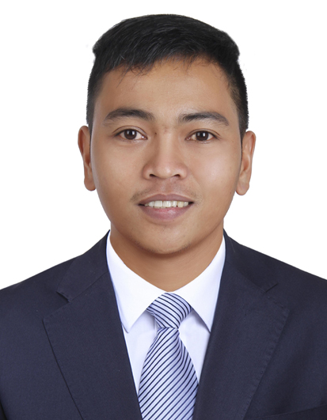
JUMAR.335226@2freemail.com
Desired Position: Computer Hardware and Software Servicing,
Computer Technician, Retail Salesperson, Sales Assistant

OBJECTIVES:
To obtain a position that will be enable me to exercise and grow my experiences, skills, education, background and ability to work well with people.

KEY SKILLS:
- Providing first level technical support to customers.
- Ability to convey technical solutions in a clear and concise manner.
- Installing and configuring computer hardware systems and IT software.
- Escalating unresolved problems to other support staff.
- Quickly responding to customer’s enquiries and concerns.
- Undertaking analysis, diagnosis, and resolution of client’s problem via phone, email and face to face contact.
- Taking ownership of problems and tracking them to a successful conclusion.
- Analysing call logs to spot trends and underlying issues.
- Producing documentation and reports to a high standard.
- Testing and evaluating new technology.
- Setting up new user’s accounts and profiles and dealing with password issues.
- Monitoring IT network to ensure availability to all users.

WORK EXPERIENCES:

FREBROS TECHNOLOGY

Tacurong City, Sultan Kudarat, Philippines
May 2014 – April 2016

Position : Computer Repair Technician cum Sales Clerk

Job Description:
- IT Maintenance
- Networking
- Software Application
- Software Configuration/Installation
- Printer Repair/Installation
- CCTV Installation
- Troubleshooting (Software and Hardware)
- Customer Service
- Selling Computer Products

- Marketing
- Encoding

OCTAGON COMPUTER SUPERSTORE
Gaisano Mall of Davao, Davao City, Philippines
August 2011 – February 2011

Position : Sales Assistant

Job Description:
- Greeting customers who enter the shop.
- Be involved in stock control and management.
- Assisting shoppers to find the goods and computer products they are looking for.
- Answering inqueries from customers.
- Giving advice and guidance on computer products selection to customers.
- Responsible dealing with customer complaints.
- Working within established guidelines, particularly with computer brands.
- Responsible for security within the store and being on the look out for shoplifters.
- Receiving and storing the delivery of large amounts of stocks.
- Keeping up to date with special promotions and putting up displays.
- Keeping the store tidy and clean.

BENCH MEN’S CLOTHING
SM City Davao, Davao City, Philippines
May 2010 – June 2011

Position : Retail Salesperson

Job Description:
- Greeted customers and determine each customer wants or needs.
- Directs customers by escorting them to racks and counters; suggesting items.
- Advises customers by providing information on products.
- Helps customer make selections by building customer confidence; offering suggestions and opinions.
- Responsible for maintaining clothing and merchandise in a presentable manner.
- Maintained details related to each sales.
- Bagged, packaged, exchanged, and accepted return purchases, and wrapped gifts.
- Successfully handled incoming merchandise and prepared it for purchase.
- Worked effectively with the entire team to ensure customer expectations were met.
- Responsible of opening the store each morning.

INTERNSHIP:

FREBROS TECHNOLOGY

Tacurong City, Sultan Kudarat, Philippines
February 2013 – April 2013

Position: On-the-Job Training

Job Description:
- IT Maintenance
- Software Application
- Selling and Marketing
- Troubleshooting/Software & Hardware
- Networking

FREBROS TECHNOLOGY

Tacurong City, Sultan Kudarat, Philippines
February 2014 – April 2014

Position: On-the-Job Training

Job Description:
- Troubleshooting
- Networking
- Customer Service
- Selling and Marketing
- Encoding

ACADEMIC QUALIFICATION:

DIPLOMA IN INFORMATION AND COMMUNICATION TECHNOLOGY

Moverstate Institute of Science and Technology Inc.

Davao City, Philippines

Graduated Year 2014

