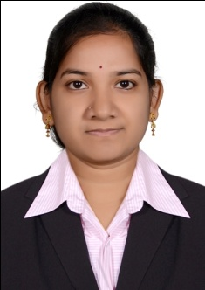
CURRICULAM VITAE

SWATHI
SWATHI.335238@2freemail.com

OBJECTIVE
I am extremely motivated and striving for a career in which I can achieve a high standard of success. I am initiative and prepared to work smart to attend my goals. I am ambitious willing to learn and grow on the job.
A BRIEF OVERVIEW
- A dynamic professional with 2years of solid experience in Accounts& Finance.
- Well versed with Accounting Packages of Tally, Focus,& Wings, Peachtree.
- Energetic with High personal integrity
- Propensity to learn new things
STRENGTHS
- Smart Work
- Positive Attitude
- Desire to Learn
- Good Communication Skills
EDUCATIONAL PROFILE
- Master Of Business Administration M.B.A (Finance) from India (65%) 2010-2012 Osmania University.
- Bachelor of Commerce (B.Com) from Siddhartha Degree college, India (65%). 2006-2009 Osmania University.
- Intermediate Commerce (CEC) from Pranathi Junior College, India (82%). 2004-2006 Board of Intermediate.
- SSC from Jyothi Bala Mandir High School, India (65%). 2004.

COMPUTER SKILLS & TECHNICAL SKILLS
- Proficient in MS office (Word,Excel,Power point)
- Type Writer Lower Qualified
ACCOUNTING PACKAGES
- Tally E.R.P, Focus, Wings
- GULF PACKAGES – Peach Tree, Quick Books
WORK EXPERIENCE
- Worked as an Accountant (Receivables/Payables) in Venkateshwara Marketing (Poultry feeds & Supplements) from May-2012 to June-2014 in India.
Responsibilities:
- Handling of Collection Cash & Petty Cash for Whole Branch
- Maintaining of Payroll details of the Branch Employees.
- Documentation of Vouchers, Challans & Invoices
- Daily check of open items in Accounts Payables sub-ledger and ensuring clearance of all items.
- Provide support and documentation for daily payment proposals to ensure 3rd party suppliers and associates are paid as per the payment terms.
- Assisting in month end closing
- Rigorous Follow up on payments
- Verification of sales with sales register
- Bank postings & Reconciliations
- Maintaining of Books of Accounts of the clients
PERSONAL DETAILS
Date of Birth : 21-09-1988
Nationality : INDIAN
Marital Status : Married
Language Known : English, Hindi, Telugu
Visa Status : Husband’s Visa

