Arsalan
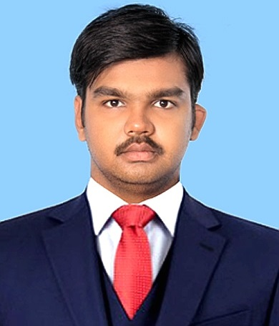
Email: arsalan.335247@2freemail.com

Profile

A highly motivated diploma holder Engineer, with versatile 2.5 years of experience in the field as Technical Officer & General Electrician. Seeking further a challenging job position as Electrical Engineer in a leading organization where my extensive engineering skills, professional entrepreneurial experience & extreme expertise of application development abilities will be fully utilized with continued career growth.

Key Skills

- Excellent presentation & communication skills.
- Dedicated, proactive, hardworking & ability to withstand work load & pressures.
- Ability to create business relationship & work well with people internally & externally.
- Enthusiastic, versatile, problem solver, juggles multiple tasks, responds creatively and quickly with conventional or unconventional solutions.
- Ability to maintain confidentiality.
- Ability to generate innovative ideas.

Professional Experience

- PAKISTAN CABLES LIMITED – Karachi
As “Technical Officer” in Plant Engineering Dept. (from June 2016 till Date)
Key Responsibilities:
- Currently working in Engineering Department as Technical Officer and reporting all the findings to the Sr. Deputy Manager Maintanence.
- Handling external contractors like (Orient Energy Systems, 5 star Engineering, Allied Engineering & services, AVS and Haidery Enterprises)
- Maintain daily genset breakdown report and report all the findings to Engineering Secretary.
- Handle and monitor different substations present in the departments and to lead the team, which is responsible for troubleshoot in different problems regarding Utilities & HVAC (such as Single phase, 3-phase Motors and Pumps connections & Overhauling, Chillers Cooling towers, Lights, Fans, Ac’s, Security Camera’s, Solenoid valve, Electric Heaters, Steam generators etc.)
- Responsible to maintain overhead cranes and Hoists from all expects (Electrical and Mechanical both), and handling various types of industrial instruments in Plant Engineering (Utilities & HVAC)
- Managing data, preparing daily breakdown, maintenance and respective reports.
- Responsible to arrange team and perform Preventive Maintanence on machines to minimize break down time & report all the finding to Sr. Deputy Manager Maintanence.
- Play an active role in installation & commitioning of new Machines Like, 630 buncher (Neihoff India), AutoCoilers C1860 (YA SHI), Multiwire Drawing (Neihoff India)
- Prepare and Keep Maintane Records of Utility Bills, Payroll of Contractor’s Persons, Power Factors,Power Consumption etc.

- PAKISTAN CABLES LIMITED – Karachi
Apprentice as “General Electrician” (from Sep 2014 to June 2016)
Key Responsibilities:
- Previously works in Engineering Department as Calibration Incharge and reporting all the findings to the Calibration Officer.
- Works with dual charge as Predictive Incharge and reporting all the findings to the Deputy Manager.
- Handling the preventive team and preparing the respective reports.
- Daily inspect, maintain and service Electrical machines (AC/DC motors), used for manufacturing of MV/LV cables in Break down hours.
- Handling temperature controllers, thermocouples and PT100.
- Working of line speed meters and Rpm meters.
- Working of length counter meter, digital and analog both encoders and proximatory sensors.
- Also handling various types of industrial instruments related calibration, predictive, hvac etc.
- Identify & proposing improvements of existing electrical network.
- Managing data, preparing daily breakdown, maintenance and respective reports.
- Also have successfully conducted ISO 9000 & 2008, HSC Internal & External Audits.
- Handling external contractors like Prime Engineering, Instrument Kraft, Al Habib Engineering, Hyderi Enterprise’s, Ahtisham Engineering, SWS, SGS, Best power UPS, Systec, Akhter Brothers etc.
- Working, servicing and maintenance of weingh scale of 500 g to 20,000 kg.
- Preparing new machines commissioning reports as an active team player and reporting the findings.
- Preparation & implementation of preventive maintenance plans for all electrical equipments.
- Ensure compliance with safety requirements & standards procedure, defined.
- Knowledge of trouble shooting the pressure sensor, smoke detector, Gas devices, Pt 100, Thermocouple, solenoid valve, relay logic, Automation control components etc.

Software / Other Expertise

- AutoCAD Certificate Course from “Skill Development Council Karachi”
- Hardware Repair course (Assembling & Maintenance) from “Roshni Computer Institute”.
- Computer Maintenance course from “Saver System Technology”.
- Certificate course in MOUS (Microsoft Office Use Specialist) from “Farooq-e-Azam Computer Institute”.
- Operating Systems such as Server, Windows XP, vista, windows 7 & 8.1.
- Internet Surfing.
- English Language & Advance English Language course from “Domino”.

Professional / Academic Qualification

- DAE (Diploma of Associate Engineer) in “Electronics” from Aligarh Institute of Technology – 2014.
- H.S.C from Govt. Degree Collage Karachi – 2011.
- S.S.C from Brilliant Career Secondary School – 2009.

Personal Information

- Date of Birth : 7th April, 1993
- Nationality : Pakistani
- Religion : Islam
- Marital Status : Single
- Hobbies : Watching Current Affair Programs, Cricket.
- Languages : English & Urdu
- Visa Status : Valid UAE visit visa till 31st Jan 2017.

