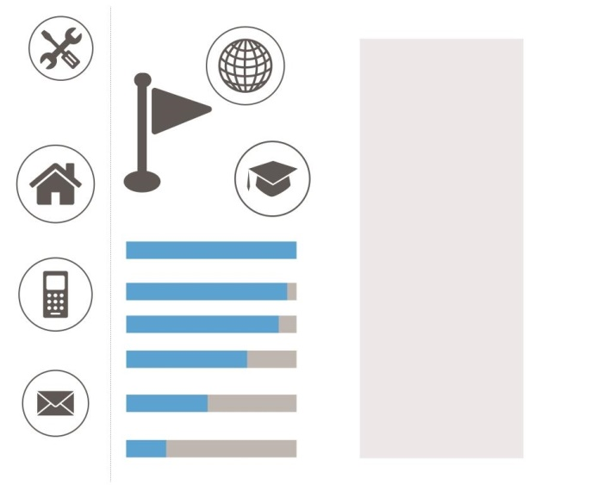RUBY



**WORK EXPERIENCE**

**Relationship Executive** Jamshedpur(IND)

at **State Bank of India -** Dec 2011 - Dec 2013

* Setting up meetings with new clients
* Researching the latest products and regulations
* Looking for new sales opportunities
* Excellent Networking capabilities
* Sound knowledge of product
* Good communication and presentation skills
* Ability to deal with stress and follow procedures
* Good Sales and Negotiation Skills

**Primary School Teacher** Jamshedpur(IND)

at **Ramakrishna Mission High School -** Nov 2010 - Nov 2011

* Ensured that students were welcomed into a positive environment conducive to learning
* Taught a variety of subjects including mathematics history and basic science
* Established positive relationships with students and provided tutoring when necessary
* Responded to inquiries from parents
* Excellent ability to engage with students
* Ability to put together customized lesson plans

**EDUCATION**

**Bachelor of Commerce** - **Accounts Honors**

from **Graduate School College for Women** Jamshedpur(IND)

April 2002 - September 2005

**Senior Senondary School (SSCE)**

from **Netaji Subhash Public School- CBSE** Jamshedpur(IND)

April 2000 - March 2002

**TRAINING AND CERTIFICATION**

**Computer Training Course** Kanpur(IND)

at **The Institute of Chartered Accountants of India**

December 2005 - December 2006

**Articleship Training for PE-II** Jamshedpur(IND)

at **Govind Agarwal & Associates**

November 2006 - January 2008

**Banking Relationship**

**Executive**

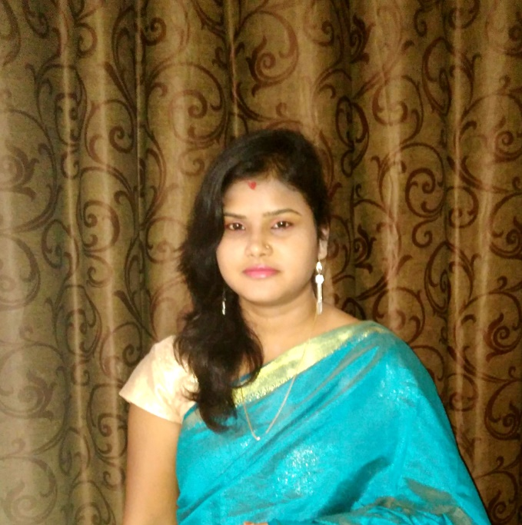

**PERSONAL DATA**



Born. 06.02.1984 India



[Ruby.335254@2freemail.com](mailto:Ruby.335254@2freemail.com)



**SKILLS**

Journal Entry

Debit and Credit

Depreciation

MS Word

MS Excel 

MS PowerPoint

**LANGUAGES**

English

Hindi

**HOBBIES**



Travelling, riding bike

and movies