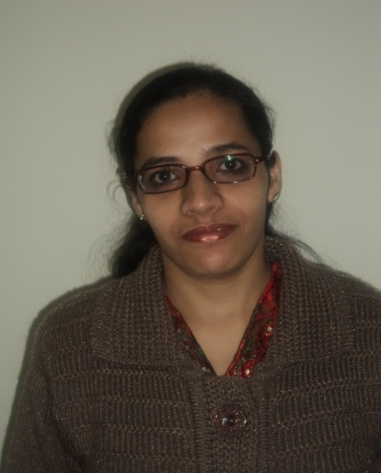

Riddhi

PERSONAL INFORMATION
Name: Riddhi
Email Riddhi.335260@2freemail.com
Date of Birth: June 27, 1980
Place of Birth: Thane – Maharashtra – India
Gender: Female
Civil Status: Married
Childrens: 1 Daughter
Nationality: Indian
Mother Tongue: Sindhi
Languages known: English, Hindi, Marathi and Sindhi
Visa Status: Holding Husband Visa
Computer Diploma in Microsoft Office 2000(MS Office)
From CMIT Computer centre Mumbai
Typing English Typing @ 30 WP M

EDUCATIONAL BACKGROUND
- Bachelor of Commerce ♦ 2003 Mumbai University, India
- Higher Secondary Certificate ♦ 2000 Mumbai Board, India
- Maharashtra State Board School Certificate ♦ 1998 Mumbai Board, India

Work Experience
1.Vodafone Essar Ltd : ROAMING Assistant / ROAMING SUPPORT / Marketing Executive in Corporate Marketing Dept
2. Vodafone Essar Ltd : Senior Executive in Collection Dept
3. IndiaIdeas.com Ltd. registers of BillDesk.com : Customer Care executive

4. Hutchison Max Touch Pvt. Ltd : Back Office Assistant & Corporate Telecaller

Details as follows
I] Work Experience

Worked with Vodafone Essar Ltd. as a ROAMING Assistant / ROAMING SUPPORT / Marketing Executive in Corporate Marketing Dept

Period:

Since Oct’2007 till March 31, 2009

Key Deliverables:
- Managing SIM card inventory (9046 cards across 9011 operators)
- Managing agreements with over 450 international operators and 65 national operators for all the Vodafone Circles (over 2000 agreements)
- Catalogue and distribute technical and billing documents for over 450 International operators and 65 national operators for all the Vodafone Circles.
- Other Roaming updates

Job Profile:

- Sim Inventory Audit
- Conducting Sim Audit
- Checking & Reverting Mails related to all general queries
- In charge of Sim cards Inbound as well as Outbound
- Updating records of sim cards
- Sending Sim Cards to Circles & Various International Operators for testing purpose
- Sending emails to Circles & International Operators for the same
- Taking confirmation via mail
- In charge of Activation & Deactivation of Sim Cards
- Mailing it to Activation team for Activation & Deactivation of sim cards
- Mailing the sim details to Circles & International Operators

- International Roaming Agreements
- In charge of International Roaming Agreements signed with Various International Operators
- Co-ordinating with Revenue Assurance Dept., Function Head, Legal Head., Corporate Heads & VP Finance for International Roaming Agreements
- Sending one copy to International Operator & keeping one copy for official records
- Maintaining records for Agreements signed with various Circles & International Operators

- Document Updations
- Checking & Reverting Mails
- Updating records for the changes done in the company (for e.g. Change in contact person, change in IOT, etc)
- Updating documents & Informing to every relevant person via mail for any change in the company

II] Work Experience

Worked with Vodafone Essar Ltd. as a Senior Executive in Collection Dept

Period:

Since May ‘2007 till Oct’2007

Job Profile:

- Handling team of 4 people & Taking Report & Guiding them
- Corporate Telecalling
- Maintaining Daily Report of Telecalling
- Solving issues raised by Corporate Company’s , subscribers’ & Agencies
- Sending duplicate bills to subscribers’
- Arranging Courier Pickups
- Maintaining MIS for Daily Report , Telecalling & Courier Pickups
- Making Monthly Reports
- Checking & reverting mails of customers
- Co-ordinating with different departments & resolving issues raised by company.
- Doing reconciliation of accounts related to payments

III] Work Experience

Worked with IndiaIdeas.com Ltd. registers of BillDesk.com as a Customer Care executive

Period:

Feb ‘2006 till Apr ‘2007

Job Profile:

- Handling BOI (Bank Of India) querries like confirming account numbers details from all branches for failed transactions

- Handling Corporate Electricity bills like Airtel, Hutch, Rim, Tata Indicom

- Handling Inbound & Outbound calls of BillDesk Customers

- Interaction with customers across the counter & over the counter all over the country

- Handling querries related to Non-Payment of Electricity Bills, Telephone Bills & Cellular Phone Bills throughout India over 15 cities of BillDesk

- Handling querries related to Tata Indicom Bills, Mutual Funds Bills, TATA-AIG, Life Insurance Premium ECS, and Kotak Mutual Fund Etc.
- Taking note of request of customer related to changes and rectification of customer account such as Addition of new biller in the existing one, Non-Receipt of Notification of payment mails from BillDesk.com, Payment Confirmation, Cancellation of Account with BillDesk etc,

- Co-Ordination with concerned departments and getting work done requested by the customers and inform the customer through phone via email

- Checking & reverting mails of customers

- Maintaining Daily Report

IV] Work Experience

Worked with Hutchison Max Touch Pvt. Ltd. a multinational company providing services in Mumbai as Back Office Assistant & Corporate Telecaller

Period:

Dec ‘2003 till Feb ‘2006

Job Profile:
- Corporate Telecalling
- Maintaining Daily Report of Telecalling
- Solving issues raised by Subscribers’ & Agencies
- Sending duplicate bills to Subscribers’
- Arranging Courier Pickups
- Maintaining MIS for Telecalling
- Maintaining Daily Report

