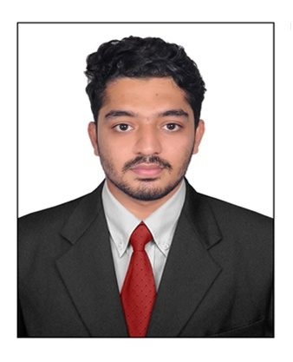
SHAMNAS S M – CV NO: 2011614
System Administrator
Dubai, U.A.E

OBJECTIVE

With an experience in Network Administration more than two year, intend to take up a responsible position in the I.T field where the area of activity includes Computer networks, Server Administration, Desktop support, VoIP network administration and also where my skills and hard work would be of value and to grow with the organization where I work, learn and earn certifications in new technologies.

PROFESSIONAL EXPERIENCE

Job Title : Network Administrator
Company : Bangalore, India
Duration : July 2014 – September 2016

SUMMARY OF EXPERIENCE

System Administration:
- Installing and configuring computer hardware, operating systems and applications.
- Monitoring and maintaining computer systems and networks.
- Troubleshooting system and network problems and diagnosing and solving hardware or software faults.
- Providing support, including procedural documentation and relevant reports.
- Setting up new user accounts and profiles and dealing with password issues.
- Installing, Configuring and Administrating Microsoft Windows 2003 / 2008 Servers.
- Installing, Configuring and Administrating Via Microsoft Active Directory Services.
- Hands on experience in troubleshooting of Backup & Restore Jobs.
- Configure and Maintain Additional Domain Controller, DHCP, and DNS Server.
- Maintaining Client Computers, Domain user accounts, local User Accounts, Logon procedures, setting up New Users, Deleting & Disabling User Accounts, User Profiles and Logon Restriction.
- Implementing & Administrating Group Policy.
- Provide Support On Microsoft Windows Server Implementation and Migration.
- Troubleshooting Microsoft Directory Services and Windows OS Related Issues.

IP Telephony:

- Configuration of various features in Cisco Unified Communications Manager and CME
- Configuration of Voice Gateways and SRST.
- Bulk Administration (BAT) of IP Phones and IP Communicator (CIPC).
- Configuring Call Manager User Features and Services.
- Configuration of Extension Mobility.
- Configuring and troubleshooting of PRI (E1 and Tss1), BRI, ISDN BRI, T1/E1 CAS.
- Understanding of various call control protocols like MGCP, H323 and SCCP.
- Configuration of VoIP & POTS dial-peers, Route patterns, Route lists, Hunt Lists.
- Configuration of Call Manager express (CME) on Cisco routers.
- Troubleshooting of Voice Interfaces: FXS, FXO and ISDN E1/T1.
- Configuration of Voice VLAN.

TECHNICAL TRAINING:

- MCSA -Microsoft Certified Solutions Associate.
- CCNA -Configuration of router, switch, VLAN, ACL, telnet, switching and routing.
- CCNA Voice -Cisco Certified Network Associate -Voice
- CCNP Voice -Cisco Certified Network Professional - Voice

ACADEMIC PROFILE

- Diploma – Computer Science from Kerala Academy of Engineering(2010-2013).
- HSE from Kerala Higher Secondary Board (2008-2010).
- S.S.L.C from Kerala High School Board (2008).

PERSONAL DETAILS

Nationality : Indian
Date of Birth : 25th May 1993
Marital Status : Single
Gender : Male
Languages known : English and Hindi.
Visa status : Visit

Declaration:

I hereby declare that the above stated information is true to the best of my knowledge and belief.

Shamnas sm.

Shamnas SM – 2011614
To interview this candidate, please send your company name, vacancy, and salary offered details along with this or other CV Reference Numbers that you may have short listed from http://www.gulfjobseeker.com/employer/cvdatabasepaid.php
addressing to HR Consultant on email: cvcontacts@gulfjobseekers.com
We will contact the candidate first to ensure their availability for your job
and send you the quotation for our HR Consulting Fees.

