 |  | CARRICULAM VITAE
Name: | Vishal
Email Vishal.335331@2freemail.com
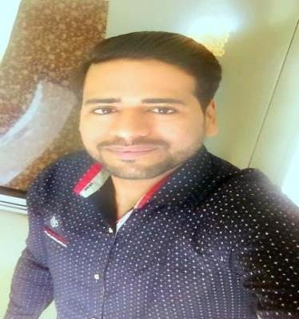
----------------------------------------------------------------------------------------------------------------------

Career prospect:

To make a positive impact in my field of activity leading to organization growth by putting all my efforts in the work assigned to me in an organization where I can grow along with organization.

Career Summary:

- 1 year of experience as a Sales executive in Mahbrook jewelers- Sharjaah at a pay of 2,500 Diram.

- More than 3 years of experience in customer dealings at own proprietary business.

Role:

- Sale of pure gold to retail customers as well as shop-keepers and build the relationship to make them regular.

Core Qualities

- Hard working and trustworthy.

- Q u i c k learner.

- G o a l oriented.

- W e l l organized.

- T e a m player with the ability to work alone if required.

Customer service skills
- S t r o n g communication skills.

- A reliable and friendly team member.

- F l u e n t in English.

Educational Qualifications:

- Completed “Bachelors of Commerce (B.com)” with distinction from “S.P. University, Anand” in the year 2014.

- H.S.C. in Commerce with 78% from D.N High School in the year 2011.

- S.S.C with 68.00% from D.N High School in the year 2009.

Personal Details:
Date of Birth |  | : | 03/11/1993
Languages known |  | : | Gujarati, Hindi, English and Sindhi
Hobbies |  | : | Travelling, Reading news, Music, Cooking

Declaration:

I hereby declare that the above mentioned details are true to the best of my knowledge.

