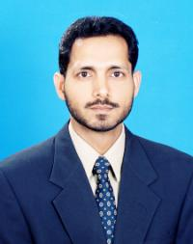
Syed

Syed.335333@2freemail.com

Personal Profile

I am a hardworking, motivated and well organised ESL/EFL teacher. My professional career is well furnished with a professional degree i.e. M.A. in TESOL as well as work experience that diversifies from teaching to administrative jobs.

Professional Training and Development

- Teaching Vocabulary and Pronunciation (Cambridge English Teacher, Online Professional Development)
- Teaching Writing (Cambridge English Teacher, Online Professional Development)
- Professional Development Workshops attended at ELI, JIC by British Council and Cambridge
- Spelt International Conference, EFL Classrooms attended at Aga Khan University, PK

Education

Degree Course Institution Date

M.A TESOL University of New South Wales Year 2004
Sydney, Australia
COTE Certificate for Spelt House, Karachi, Pakistan Year 2002
Overseas Teachers
of English

B.A Bachelors of Arts University of Karachi, Pakistan Year 2000

Work Experience

From—to Job Title Organization

Sep. 2006 to date English Lecturer Jubail Industrial College
Sep. 2004 to Aug. 2005 District Manager Jama-e-Milia (NGO)
March 2000 to Aug 2002 Course Coordinator Qamar Bin Hashim High School

