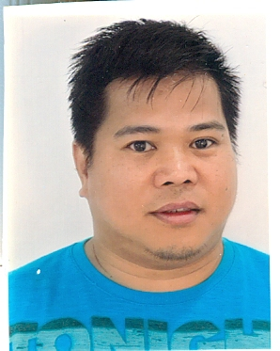
Curriculum Vitae
Ruel
Ruel.335336@2freemail.com

Position Applied: IT Administrator/IT Technical Support/ IT Staff

Objective: To obtain a responsible and challenging job in the information technology wherein I can contribute to the great success of the organization and to embrace the dynamic of challenges of today workplace.

Employment History:

( GPC ) GWAEM PRECAST CONCRETE.
Address: Old al Kharj Road Riyadh K.S.A.
Start Hired: April 11, 2005 April 11 2016

Position: IT Technical Head / System Administrator

Job Description:
- Networking and hardware engineering experience of implementing land and wireless network, in multi-platform environment.
- Installed server under windows administrated enterprise network.
- IP networking planning design, troubleshooting and management.
- Network Security and anti-virus
- Continuous learning for , creativity leadership team builder and player skill
- Developing and evaluating the IT development stragedy.
- Networking monitoring tool , networking services technology
- IP configured both DHCP and static.
- IP phone configure
- Nortel phone installation and configure

RC Computer Shop ( Own )
Cabuyao Laguna Philippines

Start: Febuary 2003 – December 2007

Job Description:
- Networking cable setup for internet café. ( games, Computer peripherals. Printer and server.
- Home service repair for personal computer and laptop, printer and scanner etc.
- Computer upgrade including motherboard and processor, memory etc
- Computer installation of window request by client

United Inrernational Trading Co.
P.O Box 61561 Riyadh K.S.A
Start: January 2001 – 2003

Position: IT Technical Support

Job description:
- Preventive maintenance in the ministry of interior, such as installation of windows per request.
- Provide technical assistance to salespeople in the sales process including product demonstration and configuration.
- Comprehensive knowledge and proficiency in MS windows server4.0 and other commercially software programs.
- Nerwork cable installation using coxial cable category 5 UTP.
- Configuartion and installation of latest Power Mac pc9500, G3 G4 Power book version 10, 9.2

Internet world café
City center Jeddah K.S.A
Start: October 1999 – 2000

Position: Computer Technician

Job description:
- Maintaining all computer Station Units ( 50Pcs)
- Installation of windows server and windows user
- Computer repairing for our shop
- Teaching internet for the new user
- Scanning all kind of paper work and editing Photoshop

Quanta Computer Corp.
Wu-chuan 3rd Road wu-ku industrial Taipei shien
248 Taiwan R.O C
Start: March 1997 –March 1999

Position: Production Engineer ( PE1 Dept.)

Job description:
- Repairing defect notebook computer ( Laptop Dell) coming from production line.
- Analyze defect symptoms and test function
- Control defect component and material use in repairing
- Prepare summary report of daily defect units
- Testing extended units coming from production lines
- Testing durability of notebook (dell laptop computer Using Hybrid macbine
- Testing humidity and temperature for new assemble Dell laptop
- Preparing test programs such as CD-ROM, battery and other module
- Testing new component coming from supplier
- Setting programs for copying HDD machine.

Seminar/ Training
Novex Printer machine for barcoding
Dubai U.A.E
Temic Telefunken Philippines
FTI Taguig Metro Manila

