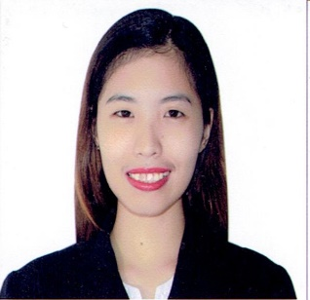
LEE
LEE.335378@2freemail.com

OBJECTIVES
Seeking a medical/healthcare position in a challenging healthcare facility where exceptional combination of theoretical and clinical skills is required to effectively perform the standard nursing procedure of assessing, planning, implementing and reviewing patients care plan.

WORK HISTORY
Ricardo Limso Medical Center
V. Ilustre Street, Davao City, Philippines
Full Time Staff Nurse
June 2013 – October 2016

Playing a key role by being responsible for the delivery of nursing services care to patients. Focusing upon assisting patients achieve the optimum level of health, administering treatment and advising on health prevention.

- Prioritizing direct patient care according to level of emergency including assessing their needs and discussing their treatment and medical care with hospital doctors and consultants.
- Assisting patients post operatively and post delivery.
- Remaining calm in difficult situations whilst at the same time being observant, adaptable and firm with patients.
- Communicate in a caring manner with patients and their family members through excellent communication skills and ability to empathize to gain a patients trust and confidence.
- Making patients aware of their treatment to ensure they are fully informed and consent to their treatment.
- Looking after patients of all ages from the very young to the very old.
- Responsible for assessing the medical history of patients and their record details and then evaluating patients and prioritizing their treatment.
- Supervising and mentoring student and newly qualified nurses.
- Involved in the administration procedures for a patients admission and also their discharge
- In hospital wards administering daily drug and medicine prescriptions to patients via parenteral or orally.
- Educating patients on matters of hygiene.
- Experience of using advanced hospital equipment and procedures including administration of intravenous fluids and chemotherapy drugs to patients, operating oxygen apparatus, administering tube feeding pumps and changing of dressings in aseptic technique.
TRAININGS/SEMINARS ATTENDED
Advance Cardiac Life Support Training
American Heart Association
22-23 June 2014

Basic Cardiac Life Support Course
American Heart Association
12 February 2014

Regular IV Training Program
Association of Nursing Service Administrators of the Philippines
April 2013

LICENSE DETAIL
Professional Regulation Commission
2nd Floor,Granland Business Center, R. Castillo St, Davao City
Registered Nurse
Registration Date: 22 March 2013
Validity Date: 02 December 2019

EDUCATIONAL ATTAINMENT
Bachelor of Science in Nursing (June 2008-April 2012)
Brokenshire College
Madapo Davao City, Philippines

PERSONAL DETAILS
Date of Birth: 02 December 1991
Nationality: Filipino
Marital Status: Single
Religion: Protestant
Visa Status: Visit Visa

___________________________________________________________________________

REFERENCES AND RELEVANT DOCUMENTS ARE AVAILABLE UPON REQUEST

