Curriculum vitae

ADHIL
ADHIL.335416@2freemail.com

Dear sir/ madam,
I am interested in applying for this position, Network Administrator.
I am graduated with BTEC HND –Networking Administrator at British college of Applied Studies and I have got more than two year in Sri Lanka experience in the field with leading companies.
As I started my career in Srilanka I have been practicing all the basics and those projects I worked in overseas made my profession in to advanced level. With all my experience, I am confident that I can handle the challenges independently meanwhile being a morally sound team player.
I have attached my updated CV and I will be looking forwarded to hear from you at your earliest I will be available in any of the mentioned contact preferably mail, if my phones are not Responding for any more clarifications, documentations or even for an interview in case of Requirement.
Thank you in advance and my best regards.

Curriculum vitae
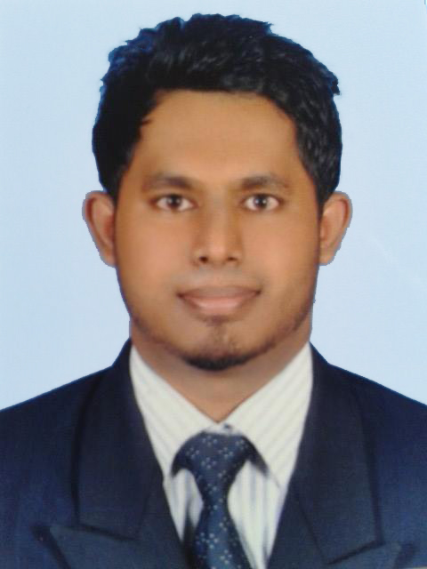
Network administrator

Objective
To obtain a challenging position as a network Administrator where can utilize my knowledge of Networking and it should help me for my career growth.

Profile
I am an open-minded friendly and resource full network Administrator with a sound and optimistic Outlook on all things in life. I possess an excellent ability to motivate others coupled with the ability to communicate comfortably at all levels, therefore ensuring an excellent working environment for all Members of the team to perform at their bests.

Work experience
X Generation No, 120 Gall Road Beruwala srilanka (2014 august – 2016 September)
Network administrator
• Computer Assembling, Upgrading and Servicing/ Troubleshooting and Repairing
• Operating System Installing and Configuring (XP, 2003, Vista, 2008, 7, 8, 8.1, & 10)
• Installing and Configuring Application Software, Virus Guards, Drivers
• Introduction to Networks (LAN / WAN)
• IP Addressing (IP V4 & V6)
• Local Area (LAN) and Wide Area Network (WAN) Concepts
• Implementation and Planning Network Infrastructure.
• Switch and Patch Panel Installation
• Installing and Configuring Windows Server 2000, 2003 & 2008 2012 and 2012 r2
• Implementing Workgroup and Single Domain Environment
• Managing Windows 2000, 2003, 2008 & 2012 Domain Environments
• Microsoft Windows Server administrative Tasks
• Installing & Configuring DNS Server and Active Directory Service
• Installing & Configuring DHCP Servers
• Installing & Configuring File Servers & Printer Servers
• Installing & Configuring Internet Information Service (IIS) web and Mail Servers
• Installing & Configuring Child Servers and Backup Servers
• Active Directory Reinstallation
• Installing a Remote Installation Server (RIS)
• Maintaining and Troubleshooting Windows 2000, 2003 2008 and 2012 Servers
• ADSL Router Configuration
• Installing & Configuring Proxy Servers
• Wireless (Wi-Fi) Router Configuration
• Wireless Networking With Windows 2003, 2008 2012 Serves
• Implementing Latest Wired and Wireless Technologies
• Cisco routers Manageable switches (Port Mapping & VLANS)
• Network firewalls.

Skills
Enough knowledge in computer methodology, computer capacity dealing with internet, e-mail and office package, manage many software’s and software’s coding’s, installing OS(windows, Linux, ma), computer dismantling and assembling, solve the software problems, hard disk partitioning, solve the internet errors, routing team management, time management, active, good listener
Education qualification
- BTEC high national diploma in network administrative in year-2014 at (E dexcel, U K) British college of applied studies Colombo 06 It would end 2015.
- Diploma in Hardware Engineering with Networking at, British college of applied studies Colombo 06 (2013)

- Diploma in English at British college of applied studies Colombo 06 (2013)

- An ACCESS Programme (Degree Foundation) at British college of applied studies Colombo 06 (2013)

Personal information

Date of Birth : February 27, 1996
Religion : Islam
Gender : Male
Citizenship : Sri Lankan
Marital status : single
Visa : visit visa

Non-related reference

Up on your request…….

