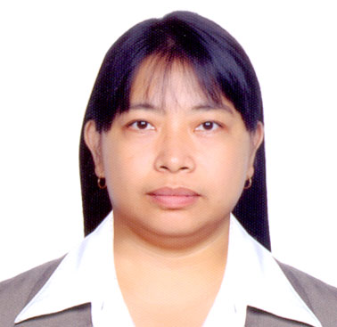MAIDA

MAIDA.335438@2freemail.com

OBJECTIVES:
To apply in a position as per my qualification in a company which offers a room for advancement to a more that dedicated and persevering candidate whose main gold is to use an acquired knowledge and experience to the best of my capabilities. I am looking forward to work a career and becoming an asset in your company.
STRENGTH:
Strong back ground in my relation field.
Gold and result oriented
A team player and can work under pressures

SKILLS:
Computer literate

PERSONAL BACKGROUND:
NATIONALITY---------------------------FILIPINO
RELIGION---------------------------------CATHOLIC
Visa Status------------------------- VISIT VISA

WORK EXPERIENCE:

POSITION: SENIOR CASHIER
SHARAF DG
AUGUST 14, 2011 – JULY 21, 2016

DUTIES AND RESPONSIBILITIES:
>Experience in cash handling and POS use
>Accepts cash, checks, wire transfers, or credit cards for payment and completes check and credit card transactions according to established procedures and guideline
>Collect and verify cash payments to ensure timely and accurate cash collection
>Inform the customer of the total purchases and also Apologize to the customer behind for the delay of the item
>Maintaining clean and orderly checkout area
>Handles store operations in the absence of the store managers
>Maintain and update daily report, monthly report and yearly report
>Get the ERP report to check all Cards for selling
>Substantial knowledge of ISO standards
>Trained to work in other section of the store
>Customer service - Taking care of the customer’s needs by providing and delivering professional, helpful, high quality service and assistance.
POSITION: SALES ASSOCIATE
KIDS STORE
BEACH CENTER JUMEIRAH DUBAI UAE
NOVEMBER 09, 2006 – DECEMBER 15, 2010

DUTIES AND RESPONSIBILITIES:
>Welcome customer with smile as they enter into premises,
>Answering proactively ask customer how they can be assister.
>Explain product features and warranty agreement
>Provide information on daily deals and promotion
>Assist customers by taking down products that may not be easy to reach
>Provide information regarding each product and any offers associate
>Respond to customer’s requests and concerns in a resourceful manner
>Create and maintain sales materials
>Prepared sales contracts and accepted payment through cash cheque and credit card
>Answering telephone calls properly
>Responsible for planning supervision and control of all the aspects of the operation.

POSITION: WAITRESS – PART TIME
GRAND HYATT HOTEL
KARAMA DUBAI, U A E
MARCH 05, 2006 – OCTOBER 13, 2006

DUTIES AND RESPONSIBILITIES:
>Always immaculately groomed in a clean full uniform
>To provide a courteous and professional service all times
>Attend to the guest queries courteously and promptly
>Report any incidents guest complaints, accidents that my occur during the course of duty
>Cooperative with team leader and management as required by the operation.

POSITION: WEREHOUSE CLEARK / STORE KEEPER
PINE FILM CORPORATION
EPZA ROSARIO, CAVITE PHILIPPINES
SEPTEMBER 01, 1996 - FEBRUARY 10, 2005

DUTIES AND RESPONSIBILITIES:
>Organizes and maintain files of record and correspondence of both a routine and confidential nature.
>Finalize and complete the work batch and shift in system on daily basis.
>Ensure that there is sufficient work load for binning to avoid lost/idle time
>Ensure that the article and the quantity being received are accurate to avoid wrong claim to vendor.
>On- time processing and dispatching of deliveries to branches and customers.
>Preparing a daily stock register which is attested by the security guard on daily basis
>Report any incidents guest complaints, accidents that my occur during the course of duty
>Cooperative with team leader and management as required by the operation.
EDUCATIONAL BACKGROUND:
EMILIO AGUINALDO COLLEGE-----MANILA, PHILIPPINES
ASSOCIATE IN RADIOLOGIC TECHNOLOGY ----GRADUATE

ATTENDED TRAININGS AND SEMINARS:
QUALITY EDUCATION AND REGULATORY BOARD------BAGUIO CITY, PHILIPPINES
THE RIGHT AND PRIVILEGES GRANTED IN ACCORDANCE WITH CONSTITUTION AND BY LAWS------------UNIVERSITY OF THE PHILIPPINES MANILA, PHILIPPINES

