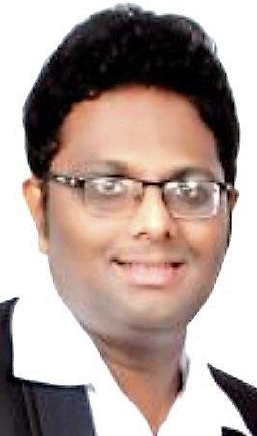
Kiran
Kiran.335442@2freemail.com

Overall 9 years of experience in IT sector, backend operations & desktop management

Areas of Expertise

- Telesales & customer service
- Team building & leadership
- Cross selling & upselling
- Complaint handling & resolution

Professional Experience

Customer service professional – Sitel India Pvt Ltd – Mumbai, India Dec 10 to Dec 16

Clients -
Money Gram International – Nov 15 to Dec 16
- Responsible to resolve technical related queries for global customers
- Handle customers with transaction related queries
- Handled supervisor calls as & when required

Dell – Dec 10 to Oct 15
- Handle technical queries from USA & Canada based DELL customers
- Trouble shooting through remote login software & resolving application related issues
- Upselling of software products to customers

Customer support engineer – Allied Digital Service Ltd – Mumbai, India Jun 07 to Nov 10

Clients –
Kingfisher Aviation Academy – Oct 09 to Nov 10
- Worked as an onsite Desktop Engineer for the Kingfisher client
- Supported desktop & notebook on site, system setup, software installations, outlook confirguration, creating mail PST, troubleshoot software issues, printer installation etc..
- Evaluation security needs of a company, implementing Patch Management & antivirus solutions
- Troubleshoot hardware & network issues, resolve application queries
- Vendor management

Essar Information Technology – Jun 07 to Oct 09
- Worked as an onsite Customer Support Division Engineer for Essar
- Installation of operating systems (Windows 98, 2000, XP, 2003 server), MS Office packs & required softwares
- Configuration of Microsoft outlook & outlook express
- Troubleshoot Hardware & Networking issues
- Worked on Advanet service desk software for logged in cases
- Experienced in AS-400 (Processing of EOD sales & inventory files, master download, SKU master initialization, tax master, repolling sales correction etc..
- Troubleshoot Windss & JDA related issues
- Remote support for desktop software problems

Educational Background:

Course / Degree | Institute / Board | Year
M.Com | Mumbai University | 2005 - 2007
B.Com | Mumbai University | 2002 - 2005

Certifications:

- CCNA (Cisco Certified Network Associate) certified – 2010
- Masters in Networking Administration from Jetking Institute - 2007
- Diploma in Basic Electronics & Computer Hardware - 2006

Software Skills:

- Platforms : Windows (98, 2000, XP, Vista, 2007, 2008 & 2010)
- System Applications : MS Office & MS Outlook
- OS/Hardware : Windows (2003 Server)
- Software : Windss, JDAMMS, SABRE, SAP, CITRIX, DELL, SERVE & IDD

Competencies:

- Quick learner & adapts well to changes and pressure at work
- Managing relationships & working efficiently with diverse groups of people
- Committed to meeting deadlines and schedules
- Leadership skills to lead projects & handle work independently

Training:

Completed numerous courses pertaining to customer service, phone & e-mail etiquette, leadership, time management & negotiation skills

Personal Information:

Date of Birth – 05 Jan 1985
Marital Status – Married
Nationality – India
Languages Known – English & Hindi
Hobbies – Music & Travelling
Visa Status – Visit Visa

