CURRICULUM VITAE
NAME : Sana  DOB : 07/11/1992  Nationality : Pakistani  Religion : Islam  Marital Status : Single  Contacts:  Email: Sana.335443@2freemail.com |  | 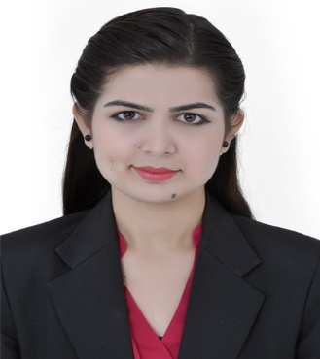
  - VISA:
  - Issue Date: Dec 10, 2017
Last Date: April 6, 2017

CAREER OBJECTIVE
Seeking for IT office job & Sales/Customer Services.
CAREER PROFILE
I am a hardworking, enthusiastic and motivated individual who has a proven record of being a trustworthy and flexible worker. I have excellent communication skills and have experience in public relation, dealing with any kind of face to face customer services. I am capable of prioritizing my own work load and experienced in dealing with customer enquiries and requests.
HIGHLIGHTS OF QUALIFICATION AND COURSEWORK’S
- Master Degree: M.S.C Zoology (Master of Science in Zoology) Passed in 2016 From University of Sargodha.  - Bachelor Degree: B.Sc. (Bachelor of Science) Major Subject, Zoology, Botany, Chemistry. Passed in 2014 from University of Sargodha. | - F.Sc. Passed in 2012 From Board of Intermediate & Secondary Education Sargodha.  - Matric. (Matriculation). Passed in 2009 From Board of Intermediate & Secondary Education Sargodha.
COMPUTER SKILLS
- Microsoft Excel
- Microsoft Word
- Microsoft PowerPoint
- Internet searching

PROFESSIONAL EXPERIENCE
- Bucha Kala Hospital ,Sargodha, Pakistan
Worked as a Receptionist for one year
Job Responsibilities:
- Welcomes visitors by greeting them, in person or on the telephone; answering or referring inquiries.
- Directs visitors by maintaining employee and department directories; giving instructions
- Deal with queries from the public and customers.
- Ensure knowledge of staff movements in and out of organization.

- Punjab Genral Store, Sargodha, Pakistan
Worked as indoor sales lady for one year
Job Responsibilities:
- Sales cosmetics
- Customer service
- Data Feeding
- Collecting and reporting post sales customer information and issues.
- Assisting Sales Managers on an as needed basis.

Core Competencies
- Internet Search. Management and Leadership Activities/Techniques.
- Relationship Building
- Excellent presentation skills
- Negotiation, communication, customer service, follow up
- Coaching Activities.
- Volunteer Work/Community Involvement
- Social Activities
- Drama, music & the performing arts
COMMUNICATION & INTERPERSONAL SKILLS
- Hardworking, trustable, reliable and self-disciplined person.
- Excellent writing and oral communication skills.
- Flexible and Versatile.
- Ability to communicate clearly and present complex matters in a clear and precise manner.
- Ability to identify, analyse and synthesize information.
- Excellent capabilities of working and adapting to turbulent and challenging environment.
- Highly self-monitored, achievement-oriented, enthusiastic and energetic.

