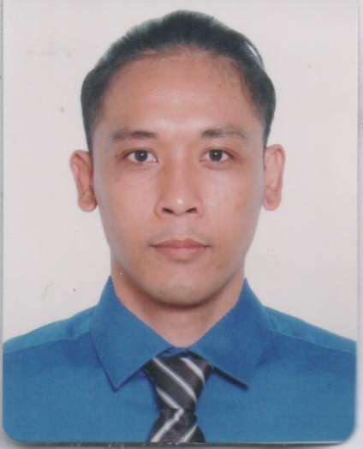
CURRICULUM VITAE
CRISANTO
CRISANTO.335458@2freemail.com

Career Objective: To be able to work in a reputable company with major responsibilities that will effectively utilize my experience, communication, leadership and organizational skills.

Skills: -Has knowledge in computer, MS Word/Excel/PowerPoint,
- Expert in PC Troubleshooting and Software Installation.
-Basic Electrical and Electronic Technician.
-Sales Assistant
-Knows how to Operate CNC LATHE Machine
-Knows G Code and program CNC LATHE Machine
-Hardworking,
-Flexibility in communication with multi- Cultural environment.

JOB EXPERIENCES:

A: SAVE ON SURPLUS
(Metro point Mall Pasay) - Sales/Computer Technician
BNK Value Marketing INC. - (2006-2008)

B: MINGHONG IRONWARE COPROCESSOR INC. OF THE PHIL.
(Tadang Sora Q.C.) -CNC LATHE Operator
MINGHONG - (November 2011-November 2012)

C: JUSTIN ENGENDERING & MACHINERY CORPORATION
(Malinta, Valenzuela M.M.) -CNC LATHE Programmer & Operator
JEMCO - (February 2013-September 2013)

D: PCHUB
(SM City Fairview Cyber Zone) -Sales / Computer Technician
LENGEND of ICE - (December 2013-November 2014)

E: FILBAR'S
(Paso de blas road, Valenzuela M.M.) -Warehouse personnel
Seasonal Employee -October-December 2015

SEMINAR ATTENDED:

February 2005: -Networking Seminar (Bulacan State University)

April 2008 - Creative Selling Techniques (BNK Value Marketing INC. Head Office)

EDUCATIONAL ATTAINMENT:

College: Bulacan State University (Sarmiento Campus)

City of San Jose Del Monte, Bulacan
Course: Certificate in two year Industrial Technology
Major in Computer Technology
(2004-2006)
Secondary: San Jose Del Monte National Trade School

City of San Jose Del Monte, Bulacan
(2000-2004)
Elementary: Paso De Blas Elementary School

Paso De Blas Valenzuela Metro Manila
(1994-1997)

F.V.R Elementary School

F.V.R Brgy. Tigbe Norzagaray, Bulacan
(1997-2000)

PERSONAL DATA:

Birth Date: May 15, 1987
Birth Place: Valenzuela Metro Manila Philippines’
Height: 5’6”
Citizenship: Filipino
Religion: Roman Catholic
Status: Married

I hereby certify that the above statement is true and correct to the best of my knowledge and belief.

