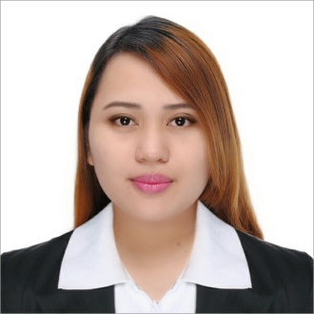 | PRECIOUS  PRECIOUS.335544@2freemail.com
- Graduate of Bachelor of Science in Computer Science in Laguna College of Business and Arts
- Born on April 5, 1989, Single, 27 years of age
- High spirited with positive outlook in life, team player, goal oriented with sense of ownership, transferrable, good learner.
- CAREER OBJECTIVES:
Seeking for an Executive Secretary/ Admin Specialist to serve the organization and add more value on the job to achieve company’s goal as well as to establish an enjoyable and long term career for myself.
- KEY COMPETENCIES:
Fundamental Business Operation and Principles Awareness, Data Management and Analysis, Marketing and Sales, Supply Chain Management, Advanced Verbal and Communication Skills, Planning and Organizing, Schedule Management, Travel Preparation, Customer Service Oriented, Knowledge and experience in relevant software application such as Oracle & MS Office.
- WORK EXPERIENCE:

Administrative Associate/ Data Specialist
Technoblue - Doha, Qatar
March 2016 to present
JOB SUMMARY: Responsible for data management and analysis. Strategy implementation such as sales target, promotions, incentives, sales forecast. Sales system operation which includes price update, invoice and purchase order creation. Responsible for organizing sales visits, demonstrating and presenting products, maintaining accurate records, reviewing sales performance negotiating contracts and packages aiming to achieve monthly or annual targets.

Executive Assistant to the President
Canon Business Machines Philippines Inc - FPIP Tanauan, Batangas
November 2012 - Present

JOB SUMMARY: Execute thorough monitoring and arranging of President Schedule and preparation of speeches and business correspondence. Responsible for handling foreign travel of President as to ticket reservation, hotel reservation and travel reimbursement. Plan and execute necessary preparation for VIP Guest. Facilitation in Management Committee Meeting and other special company activities. Preparation of Purchase Request, Cash Advance, Reimbursement, Budget etc. Engaged in Corporate Planning Activities such as CSR, Corporate Events and Corporate Communications.

Secretary to the Senior Vice President
Asia Brewery Inc - Cabuyao, Laguna
February 2011 – October 2012

JOB SUMMARY: Organizing and arranging meetings of the President. Consolidation of manufacturing related reports. Preparation of Purchase Request, Cash Advance and Reimbursement. Answering phone calls and filing papers.

HR Assistant (Timekeeper)
SM Supermarket - Real, Calamba City, Laguna
August 2010 – January 2011

JOB SUMMARY: Compilation of employee’s time and attendance.Verification and validation of timekeeping data submitted each pay period. Distribution of employee’s payslip on time. Preparation of the following documents and reports such as Security Guards Billing, Travel Allowance, Perfect Attendance, Tip Distribution and Tip Monitoring, Man-hours and Absenteeism. Orientation for newly hired employees, preparation of contracts and filing 201 data.

- PART TIME JOBS
Clerk
Municipal City of Calamba (Police Department), April – May, 2007
Municipal City of Calamba (CENRO department) , April – May, 2008

On The Job Trainee
Philippine Long Distance Telephone Company, Los Baños, Laguna , April – June, 2009

