RAHUL Curriculum Vitae

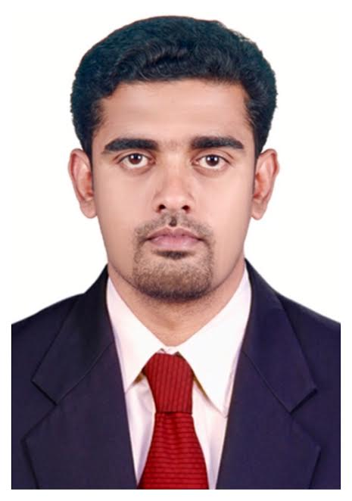

MARKETING | SALES |CUSTOMER SERVICE| MANAGEMENT|

Email:

RAHUL.335549@2freemail.com

Nationality
Indian

Languages
English, Malayalam, Tamil and Hindi (Fluent)

MARKETING | SALES |CUSTOMER SERVICE| MANAGEMENT|ADMINISTRATION

Professional Profile

Ambitiously seeking to apply my skills in a challenging a dynamic environment and to be a part of the team that wants to “make the difference “as well as driven by the “will to succeed”
In today’s highly competitive world and fast-paced market, organization needs strong and dynamic professionals to meet ever-changing business goals. Throughout my professional career, I have successfully managed to be proactive, open minded and forward looking with persistence and purpose. I am a value driven professional and believe in the maximum application of my multifaceted experience to deliver consistent result.
I am certain I can contribute this level of performance to your organization, and I invite you to consider my experience.
Professional snapshot

- A Result Oriented professional with experience in customer service, sales and Marketing.
- Abilities in coordinating with customers for running successful business operations and experience of improving procedure and service standards for business excellence.
- Skilled in ensuring delivery of high quality services to support customer’s business needs & achieving contact customer satisfaction from all operation.
- Prudent, disciplinary & self-Motivated with excellent interpersonal, communication & organizational skills with ability in sales and customer relationship.
- Proficient at maintaining cordial relationship with client, ensuring quality and service norms to achieving satisfaction and retention.
- Proven track record in achieving target, multi-tasking and ability to deliver quality work even under stress with team.

Work Experience

RIVOLI GROUP. | 2011- Present

As Senior sales associate [was awarded “best shop in charge” in 2016]
Major Responsibilities:
- Responsible for all aspects of stores.
- Meeting sales target for the shop and brand.
- Networking with prospective customers for incremental business.
- Creating & Maintaining customer’s relationships, high standards in customer service, effectively handling customer complaints.
- Ensuring high standards of visual merchandising, stores presentation and upkeep.
- Managing stocks in the location and minimizing loss of inventory.
- Marinating awareness of market trends, monitoring local competitors and customer.
- Managing and motivating the sales team to ensure increased sales & efficiency.
- Ensuring team is well presented and in full uniform always in the shop.
- Communicating and upholding all company policies, rules and procedures.
- Ensuring proper cash management at the stores.
- Preparing monthly reports, as required by the management.
- Coordinating with mall management.

COUNTRY CLUB INTERNATIONAL LLC. | FEB 2011-SEP 2011
As Direct marketing executive
Major Responsibilities:
- Achieving sale targets
- Preparing monthly sale reports
- Periodical collection of data through promotions and venues
- Fixing meetings and Cold calls with prospective clients
- Customer relationship management
MAX NEWYORK LIFE INSURANCE COMPANY LTD | DEC 2009– NOV 2010
As Associate sales manager [was awarded a certificate for “Highest Cheque Collection”] Major Responsibilities:
- Recruit and training sales advisors
- Managing and motivating the team
- Organize team meetings
- Generating business revenue and achieving yearly targets.

COUNTRY CLUB INDIA LTD.| MAY 2006– DEC 2009
As Team leader Major Responsibilities:
- Achieving sale targets through executives
- Preparing monthly sale reports
- Periodical collection of data through promotions and venues
- Fixing meetings and Cold calls with prospective clients
- Customer relationship management.

SIGNET ID SOLUTIONS PVT LTD | JUN 2004– MAR 2006
As Service technician /sales executive Major Responsibilities:
- Technical servicing for thermal printers and barcode scanners & CCTV camera installation.
- Product demonstration
- Generate business through customer reference and cold calling
- Preparing monthly sales report & customer complaints report

Education & Credentials

2000-2001 Secondary school leaving certificate (52 %)
Santha higher secondary school, Thrissur, Kerala

2001-2004 Diploma in electronics & telecommunication (56%)
Engineers Training Centre

Academic Achievement

- Participated in State Level “SCHOOL YOUTH FESTIVAL & SPORTS “

I T Skills

- MS Office, Windows and Internet research

Personal Details

Date of Birth : 15th April 1986
Address : Abu Dhabi, UAE

Sex : male
Marital status : Married
Visa status : Employment

Drivers License
Date of Expiry : 02-12-2023
Place of Issue : Abu Dhabi

Declaration

I hereby declare that all information furnished above to the best of my knowledge and can be supported by evidence if necessary.

