SHAIKH

SHAIKH.335555@2freemail.com 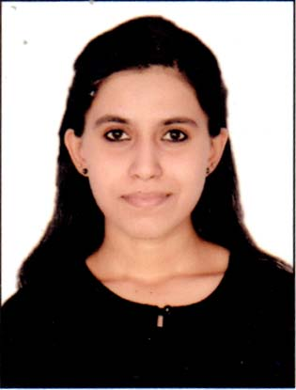

Career Objective
Seeking to continue my professionalism, where my dedication, expertise and talent will definitely bring the organization a sharper edge within the industry. Aspire for a challenging position to contribute to the company's growth, in turn ensuring personal growth.

Technical Skills
- Network troubleshooting
- Hardware troubleshooting, repair and maintenance
- Systems analysis
- Database design and implementation
- Application programming

Operating Systems: Windows and Linux
Programming: C++, C#, VB, HTML, JavaScript, CSS, PHP
Applications: MS Office, Visual Studio, Photoshop, NetBeans,
Database Systems: MySQL, Oracle,

Personal Skills
- Good verbal and written communication skills
- Motivated and always willing to learn new things
- Independent and self-sufficient in handling tasks
- Collaborative and able to work in teams or groups

Education
Bachelor of Science in Information Technology (Bsc IT)
Mumbai University (2015) A Grade
HSC (science) Mumbai University: 80.17%
SSC: 89.09%

Pre-Professional Experience
IT Intern
IT Support and Maintenance Team
Tech One Global Phils., Inc.
June 2014 – October 2014
Handled network and hardware troubleshooting in an enterprise environment. Tracked and documented IT equipment issues to facilitate timely resolution.
Student Assistant
College of Computer Studies
Patkar varde University
April 2012 – June 2014
Handled troubleshooting and maintenance of IT equipment. Provided support in monitoring and deployment of IT equipment to students and faculty.

Personal Minutiae

Linguistic Proficiency: English, Hindi and Urdu.
Visa: Visit
Preferred Location: UAE
Nationality Indian

declaration

I hereby declare that all the above furnished details are true and correct to the best of my knowledge and belief.

