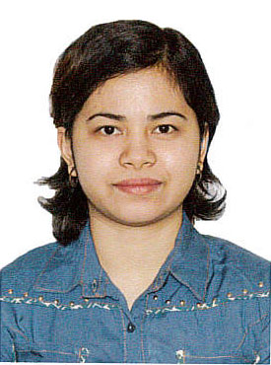

Michelle
E-mail: michelle.335567@2freemail.com

Summary: A highly motivated person to kick my career and build my skills in a reputable company. Dedicated professional, working effectively as part of multi-disciplinary team. Developed patient-centered of caring through innovative caring with practical clinical skills. Willing to accept responsibility for carrying our tasks and making sure things are done properly. Now looking forward to change my working environment, clinical trials for company that offers opportunity for career progression.

Professional Skills: Self confidence, Strong work ethic, Good time management, Works well in team, Good leadership skills, Ability to act in initiatives, Flexible, Well mannered.

Objective: A position where I can make the most of my nursing education and training, in addition to my interpersonal skills to provide the highest level of patient care.

Trainings & Work Experience
- Dental Nurse
Supports dental care delivery by preparing treatment room, patient, instruments, and materials; passing instruments and materials; performing procedures in compliance with the dental practice. Help with reception work and could help any member of the dental team - dentists, clinical dental technicians/technologists and therapists – treat patients of all ages.
Al Madar Dental Polyclinic, Ha’il City, Kingdom of Saudi Arabia
December 18, 2014 – December 20, 2016
- Basic Life Support – CPR
A level of medical care which is used for victims of life-threatening illnesses or injuries until they can be given full medical care at a hospital.
Saudi Heart Association National CPR Committee
Febuary 20, 2015
- Production Specialist
Machine operator in production and testing for the quality of integrated circuits (IC). Observes the ICs for physical damages before exports.
Texas Instruments-Baguio (TIPI) City, Philippines
July 3, 2012 – December 3, 2012
- Volunteer Staff Nurse
Direct patient care, basic drug administration, records assessment, interventions and evaluations of nursing care and makes reports as necessary.
Bacnotan District Hospital, Bacnotan, La Union, Philippines
October 2011 – April 2012
- Intravenous Therapy Training
Inserts intravenous needle, administers medication intravenously, changing intravenous solutions, administers blood transfusion, records all necessary information to patient’s chart.
Ilocos Training Regional and Medical Center
November 25-27, 2011
- Standard First- Aid Training and CPR
Red Cross City of San Fernando, La Union, Philippines
July 25-30, 2011
- The Skills Enhancement Series of NurseZoneReviewCenter
Administering oxygen therapy, inserting naso-gastric tube, intravenous therapy, insulin therapy and administration.
Union Christian College, City of San Fernando, La Union, Philippines
January 2011
- Standard First- Aid Training and CPR at Red Cross
City of San Fernando, La Union, Philippines
October 15-18, 2008

Educational Background
 | Institution | Year Graduated
 | UnionChristianCollege, San Fernando City, La Union, Philippines  - Bachelor of Science in Nursing | March 31,2011

References

Available on Request

I hereby declare that all the information provided above is true to the best of my knowledge.

MICHELLE
Applicant

