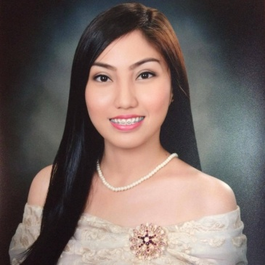
MARIA
Dubai, U.A.E.
Maria.335572@2freemail.com
Visa Status : Tourist Visa

Career Objective

To achieve eminence position that will expand my knowledge and further develop myself in the industry with the use of my skills and experiences.

Career Development

Sales Associate – SM Lucena, Department Store
(September 1, 2016 – November 30, 2016)
SM Lucena, Lucena City, Quezon Province, Philippines
- Customer Service, assisting customers on their complaints and enquiries.
- Maintain proper phasing, display of products and stocks.
- Ensure that customers are properly assisted and guided on their requirements.

Event Organizer – MILO Fun Run
(August 4, 2016- August 14, 2016)
Nestle Philippines, Lucena City, Quezon Province, Philippines
- Manage the registration & payment.
- Assisting the clients/participants on the event day.
- Information dissemination of the event program.

Receptionist
(May 2016 – July 2016)
Quezon Premier Hotel, Lucena City, Quezon Province, Philippines
- Welcoming guests to the hotel.
- Making hotel accommodation/reservation.
- Answering inquiries & checking e-mails.

Academic Background

Tertiary Bachelor of Science in Tourism Management, 2010-2016
Manuel S. Enverga University Foundation
University Site, Brgy. Ibabang Dupay, Lucena City
Secondary Quezon National High School, 2006-2010
Iyam, Lucena City

Elementary Lucena South 1 Elementary School, 1999-2006
Cotta, Lucena City

Seminars/Trainings Attended

- OJT in SOUTHERN SKY TRAVEL AND TOURS from January 25, 2016 – April 9, 2016
- Seminar on “Trends and Issues in the Workplace: A Glimpse to Hospitality and Tourism World”, AEC Little Theater, MSEUF, Lucena City, October 3, 2015
- Seminar on “How Aviation Sector and Hotel Industry keep up with Modern Customer Trends”, RBA Hall, MSEUF, Lucena City, September 21, 2015
- Seminar on “The Development and Trends in Tourism and Hospitality Industry”, RBA Hall, Manuel S. Enverga University Foundation, Lucena City, September 14, 2015
- Seminar on “Global Tourism and Hospitality Workforce: The Grand Finale”, AEC Little Theater, MSEUF, Lucena City, October 1-3, 2013
- Seminar on “Information Technology for a Strategic Tourism Management”, CTHRM Building, MSEUF, Lucena City, September 19, 2013
- Seminar on “Growing Rural Employment through Community-Based Tourism”, Dona Rosario Coffee Shop, CTHRM Building, MSEUF, Lucena City,September 3, 2013
- “7th Annual National Tourism Students Congress”, Treston Intl’ College, BGC, March 1, 2013
- Seminar on “Computer Reservation System in Gathering Information”, Manuel S. Enverga University Foundation, Lucena City, Quezon, May 28, 2012
- OJT in LUCBAN QUEZON TOURISM OFFICE (Local Government Unit) from April 9, 2012 – May 18, 2012
- “6th Annual National Tourism Students Congress”, St.Jude College, Dimasalang cor Don Quijote St. Sampaloc, Manila, February 24, 2012
- Seminar on “Branded Customer Experience”, Greenwich SM City, Lucena, February, 15 2012
- “Marketing Power Conference 2011”, De La Salle Lipa Sentrum, Lipa City Batangas, September 12, 2011
- Seminar on “Travel Enthusiasts at Work, Leisure and Experience”, Manuel S. Enverga University Foundation, Lucena City, Quezon, August 9, 2011
- Seminar on “Sustainable Tourism Development in Bulacan”, 8 Waves Water Park, San Rafael, Bulacan, Philippines, September 11, 2010

Achievements/Affiliations
- 2nd Runner-Up, Ms. Hospitality 2013, MSEUF Gymnasium, Lucena City
- Finalist, G. At Bb. Nutrisyon 2013, , MSEUF Gymnasium, Lucena City
- Member, EL TURISMO SOCIETY, MSEUF, Lucena City
- Member, TOUR GUIDERS CLUB, MSEUF, Lucena City

Personal Information

Date of Birth : August 4, 1993
Place of Birth : Lucena City, Quezon
Citizenship : Filipino
Height : 5’3
Weight : 105.5 lbs.
Sex : Female
Civil Status : Single
Religion : Roman Catholic

Special Skills

- Logically sound
- Good communication skills
- Computer literate
- Freelance Model

