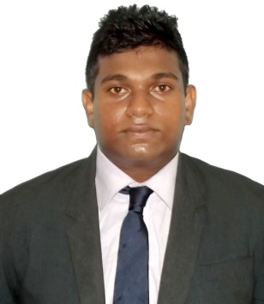
CURRICULUM VITAE

NISAL
DUBAI, U.A.E.
Email: nasal.335602@2freemail.com

PERSONAL DETAILS:
Date of Birth : 15th December 1993
Age : 23 Years
Sex : Male
Civil Status : Married
Nationality : Sri Lanka
Religion : Buddhism
EDUCATIONAL QUALIFICATIONS :
School Attended Royal College, Colombo - 07

G.C.E Ordinary Level Examination – Year 2009

Subject | Grade
English | A
Health Science | A
Buddhism | C
Sinhala | C
History | C
Dancing | C
Mathematics | S
Civics | S
Science | S

Completed a Higher National Diploma in Business Management and Human Resource at ICBT City Campus.

Completed English Language Courses in British Council (2007 – 2009)

CO - CURRICULAR ACTIVITIES

Completed Cub Scout at Royal College
Senior member of 5S Committee 2007 at Royal College
Member of Eastern Band of Royal College (2004 – 2010)
Member of school Sinhala Literature Society
Member of school Japanese society

EXTRA CURRICULAR ACTIVITIES

Member of under15 Swimming Squad at Royal College
Member of ICBT City Campus Rugby Team
Participated in inter-house Carrom Tournament

EMPLOYMENT HIGHLIGHTS
Worked at Firstsource Dialog Solutions (Pvt) Ltd., as a Customer Service Associate.

One year worked experience at The Hongkong and Shanghai Banking Corporation Limited (HSBC) as a
Personal Banking Advisor.

Currently working at McDonald’s Dubai, U.A.E. as a Manager Trainee.

I do hereby certify that the above particulars are true and correct to the best of my knowledge.

20-01-2017

