Hafiz
Hafiz.335607@2freemail.com
Personal Information
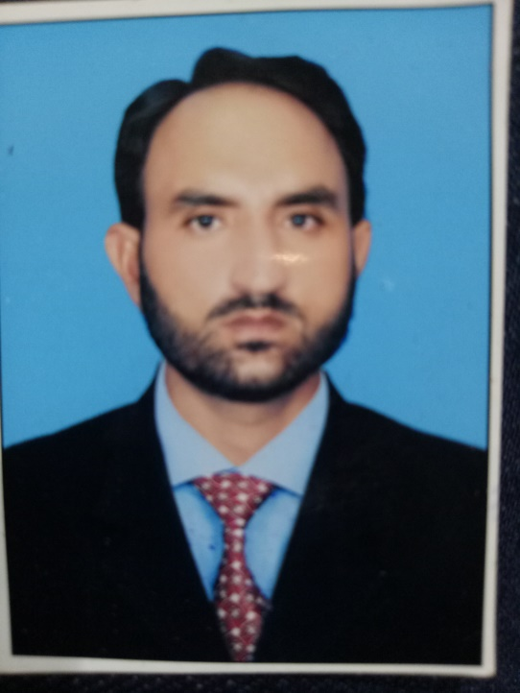
Date of Birth - 15/05/1984
Religion - Islam
Nationality - Pakistani
Gander - Male
Matriculation Board of Intermediate and secondary Education Sargodha
Division :1st Marks 526/850&Year 2005
Intermediate Board of Intermediate and Secondary Education Sargodha
Division :1st Marks 728/1100 &year 2007
Greduation Education Univeristy Okara Capus Okara
Division:1st Marks 598/850 & year 2013
HSE CERTIFICATE
IOSH Managing safely (Institution of Occupational Safety and Health)
Computer Diploma
MicroSoft (word,exel,power point) data sending and receiving & printing and Scanning etc
Experience
2year Experince as waiter & receptioner usmania resturent and hotel in Okara
7 month experience as sale man in Moscow Russia
1 year experience as a organizer in islamic acadimy of USA in Pakistan

