Anil
Anil.335621@2freemail.com 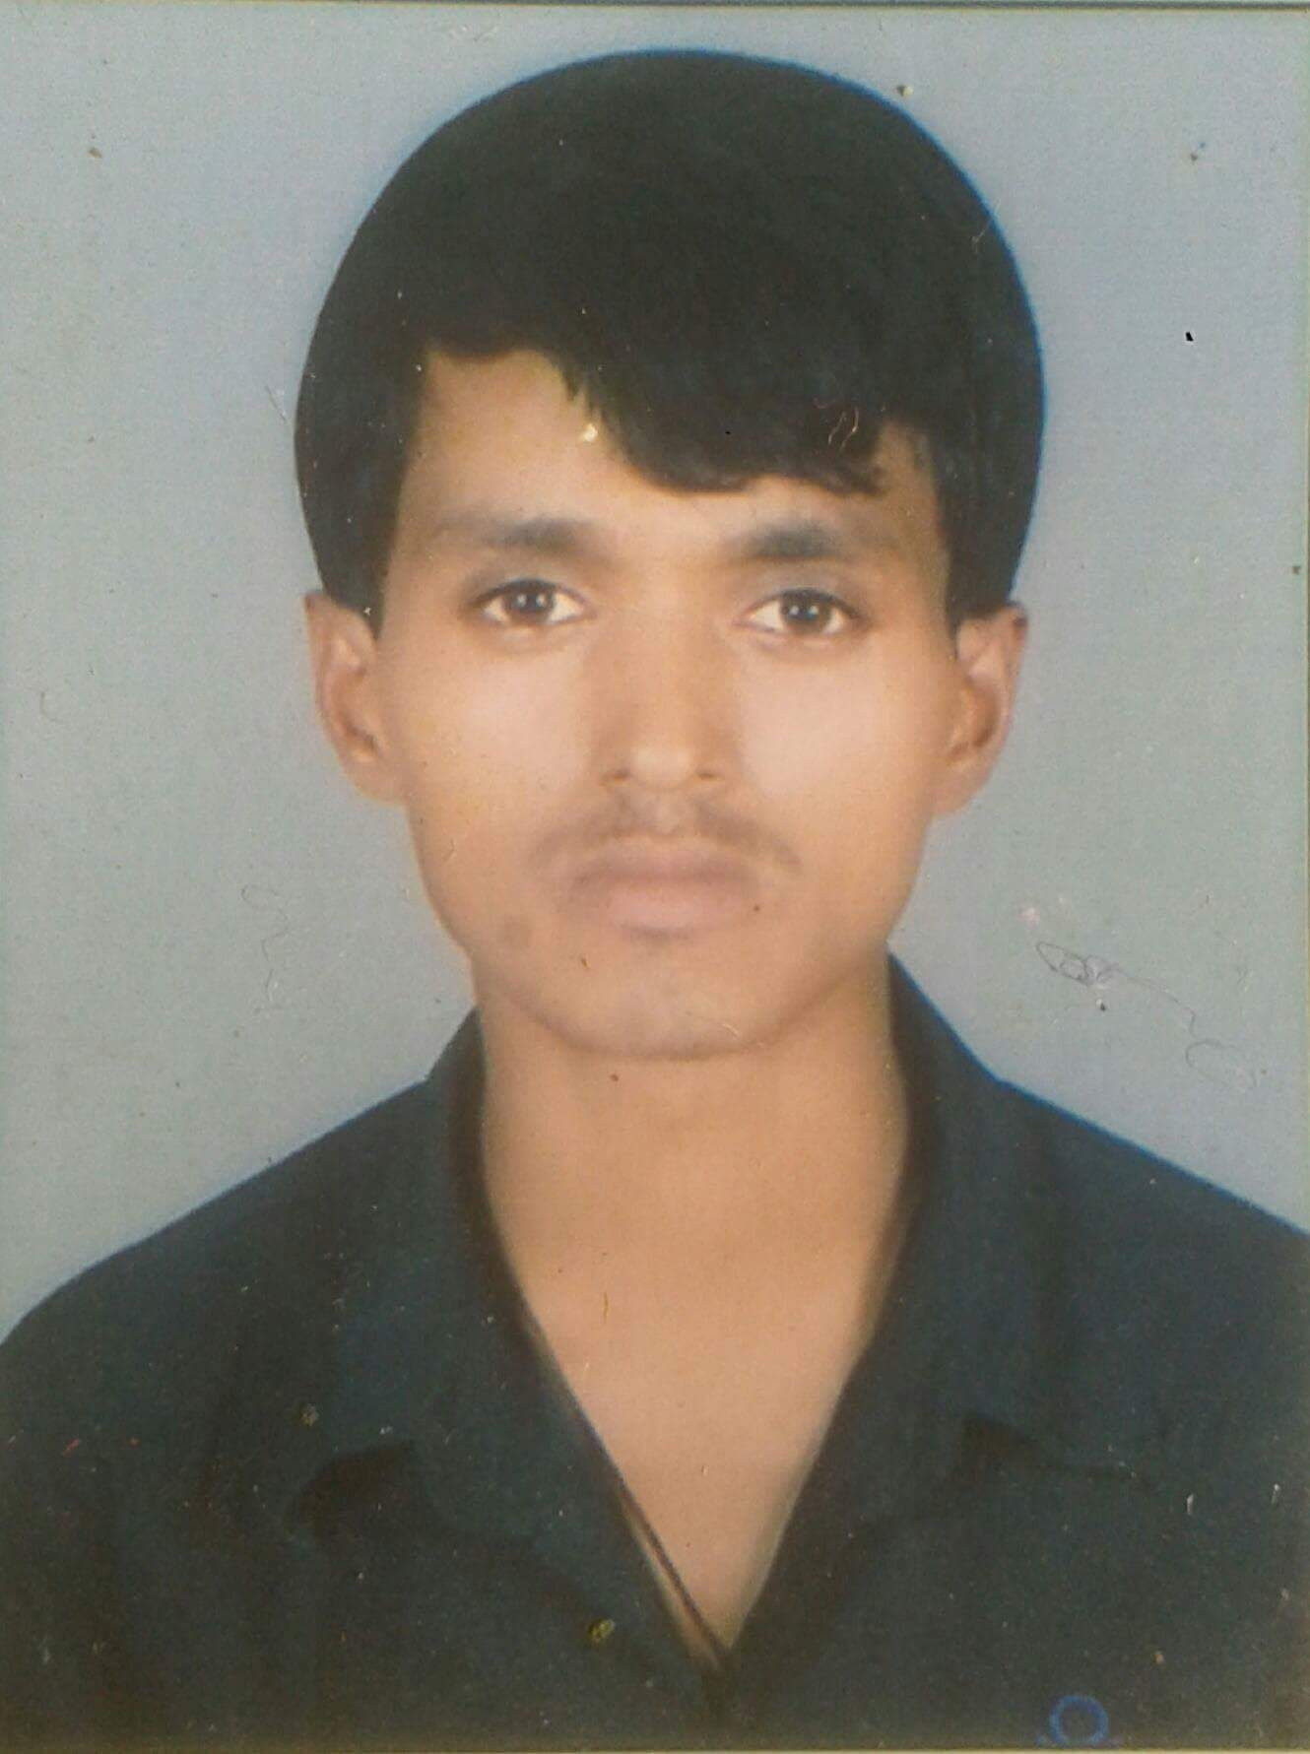

OBJECTIVE .

Obtain a position in company where I can maximize my management skills, quality assurance, program development, and training experience.

EDUCATION
May 2012 Universal cambridge english boarding school
Matriculation Examination

June 2014 ex army public higher secondary english school
Higher School Education Board

EXPERIENCE

bhat bhateni super store.
- Worked as a sales assistant merchandise in Bhat Bhateni Super Store from July 2013 to September 2014.

shrestha tailoring
- Worked as a Senior sales assistant in Shrestha Tailoring from October 2014 to November 2015.

TRAINING
- 6 months Diploma in basic computer and hardware networking from Golden Future Computer Institute.

- 3 months salesman training from Victoria international training center.

LANGUAGES

- English : Read, Write, Spoken (Fluently)
- Hindi : Read, Write, Spoken (Fluently)
- Nepali : Read, Write, Spoken (Fluently)

RESPONSIBILITIES:

- Implement and maintain all company’s policies and procedure in relation to best customer service and cash handling.
- Hardworking , flexible and fast learner.
- Reflect brand reputation throughout service in a professional way.
- Maintain floor standard as per company standard.
- Provide excellence custome service throughout the product knowledge.

PERSONAL INFORMATION

Nationality : Nepalese
Date of Birth : 27-04-1993
Place of birth : Nepal

Marital Status : Single
Religion : Hindu
PASSPORT INFORMATION
Date of issue : 25 nov 2014
Date of expire : 24 nov 2024

VISA INFORMATION
Visa type : Visit
Date of entry : 24-04-2016
Date of expiry : 24-07-2016

I hereby certify that the above-mentioned data and information are true and correct to the best of my knowledge.

