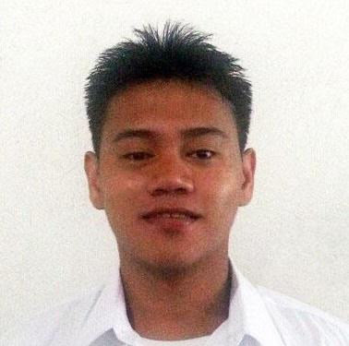
u

ARTURO
ARTURO.335635@2freemail.com

OBJECTIVES

- Looking for I.T. position where I may use my exceptional skills and knowledge of different Progamming Languages.

- To contribute superior project and operations management skills and experience in an IT Service Management role.

- I would like to implement my innovative ideas, skills and creativity for accomplishing the projects.

PROFESSIONAL EXPERIENCE

I.T. Technician and Junior Programmer
2015 - Present

Job Description

- Identify hardware and software needs of each user’s computers and take measures to meet those needs
- Provide assistance in customizing and adapting existing programs on a computer system to meet the needs of the users
- Troubleshoot problems with hardware and software on each system and provide appropriate solutions
- Connect hardware and peripherals such as printers,scanners and CCTV cameras and configure them to work properly
- Install programs and software onto each computer according to the specific needs of the user
- Ensure that computers and networks are secured by installing antivirus and antimalware applications
- Handle computer security breaches by following standardized procedures
- Perform regular and preventative physical and virtual maintenance on standalone computers and on the network members
- Monitor the security of all technological members on a network
- Assist customers and users with their hardware issues over the telephone, face to face and through emails and tickets
- Train users to handle information technology equipment by providing precise instructions
- Install/Upgrade antivirus and firewalls on computers and networks to ensure security
- Handle data backup activities by ensuring appropriate running of backup servers and drives
- Provide new users with orientation of existing technology
- Recommend purchases for both software and hardware

Graphic Artist and Machine Operator
Lady Fatima Print Saver
2010 – 2012

Job Description

- Layout Designs
- Operate Heavy Equipment Machines
- Troubleshooting Printing Machines

TECHNICAL SKILLS

HARDWARE SKILLS

- Install and configure local area data communications networks which may carry data, voice and video communications following organization standards.
- Install, operate and maintain network services, routers, concentrators, hubs, switches, modems and other network devices following technical plans.
- PC and Laptop repairs (format and troubleshooting)
- Maintaining or repairing equipment
- Setting up computer security measures
- Configuring computer networks
- Offering technical support on-site or via phone or email

SOFTWARE SKILLS

- Programming languages: (C++,VB.net,ASP.net), Java (command line and GUI), JavaScript, HTML/X
- Word processing and publication: Microsoft Word
- Spreadsheets and databases: Microsoft Excel (mssql,mysql,oracle)
- Operating systems: All Microsoft Windows
- Presentation: Microsoft PowerPoint
- Programming Language (C++,VB.net,ASP.net)

TRAININGS AND SEMINARS

2015 Preparing to be an AI Ready
Theme: “Empowering Perpetualites in the midst of Asean Integration”

2014 1st Guidance and Counseling
Theme: “Aspire, Create and Achieve”
Journeying to the Life of Success and Wellness

2013 “Cybercrime”
|Types of Cyber Crime acts and Preventive measures

EDUCATION

2012 – 2014 UNIVERSITY OF PERPETUAL HELP SYSTEM DALTA
Bachelor of Science in Information Technology

2007 – 2011 AMA COMPUTER COLLEGE
Bachelor Science in Information Technology

2001 – 2005 STA. CLARA PARISH SCHOOL

