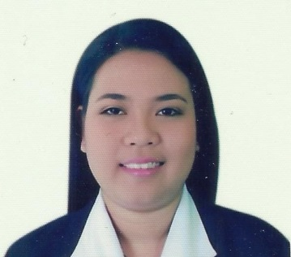
CARMINA
CARMINA.335638@2freemail.com

OBJECTIVES

To be able to enhance my knowledge, communication and interpersonal skills under your company’s supervision and believing that my work output is a reflection of my persona and to become an integral part in achieving your company’s vision.

EMPLOYMENT RECORD

REEL CINEMAS, THE DUBAI MALL
COSTUMER SERVICE REPRESENTATIVE
(Nov.5-2013- Present

MODESH WORLD
(DUBAI WORLD TRADE CENTER)
PART- TIME CASHIER
(July 17-August 28 2013)

PUREGOLD VIGAN
RECEIVING CLERK
(Aug 2012 -Feb.2013)

LEGEND HOTELS CORPS.
Housekeeping and Room Attendant
(Jan-July 2012)

KAFFE CAFFE
WAITRESS
(May-Dec 2011)

EDUCATIONAL ATTAINMENT

COLLEGE
University Of Northern Philippines
Bachelor of Science in Hotel and Restaurant Administration
March 23, 2011 (Graduate)

ADDITIONAL SKILLS
- Computer Literate
- Prepared to work shift hours based on operational needs
- Excellent in customer service and relation
- Good and willing to learn new abilities for the upcoming new technologies
- Self-motivated and ability to serve customer with minimum supervision

SEMINARS AND TRAINING ATTENDED

- SUPERFERY ABOITIZ TRANSPORT SYSTEM CORP.
G/F Harbor Center II Bldg. 2 St., Corner, Railroad St., South Harbor Port Area Manila
Vessel Familiarization Tour

- SOFITEL PHILIPPINE PLAZA MANILA (Sardonyx Tours and Travel)
CCP Complex, Roxas Boulevard, Pasay City 1300, Metro Manila, Philippines
Front Office Operations
Personality development

- OASIS RESTAURANT
San Fernando, La Union, Philippines
Personality development

CERTIPICATES AND DIPLOMA
- Food and Beverages Services NC II
- Commercial Cooking and Bartending Services NC II
- Housekeeping II and Front Office Services NC II
- Bachelor of Science in Hotel and Restaurant Administration

PERSONAL DATA:
- Birth Date: March 2, 1991
- Age: 25 Years Old
- Birth Place: Candon City, Ilocos Sur, Philippine
- Civil Status: Single
- Citizenship: Filipino
- Gender: Female
- Laanguage Proficiency: Ilocano, Tagalog, English
- Visa Status: Fathers Visa

Character references are upon request

I hereby certify that the above mentioned is true and correct according to the best of my knowledge and belief .

________________
Applicant Signature

