RESUME

JENISH  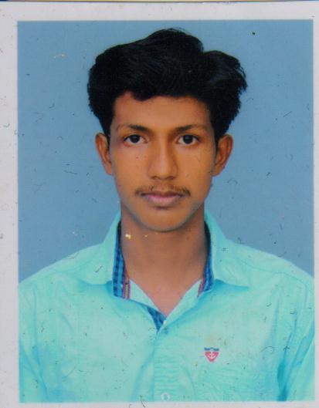  JENISH.335655@2freemail.com  Personal Data:  Date of Birth : 13/04/1994  Gender : Male  Nationality : Indian  Marital Status : Single  Language Proficiency:  - English  - Tamil  - Malayalam  AREA OF INTEREST:  - Hard Ware & Networking  - House Wiring  Extra Curricular Activities:  - Social service  - Cricket player  TECHNICAL SKILLS:  - MS Office  - Photo shop | Career Objective  To strive for a challenging position in a progressive organization. Using my skills and work towards my professional growth with the growth of organization.  Educational Profile   Qualification : BE in ELRCTRONICS AND  COMMUNICATION Engineering.  ➢ Institution : James College of Engineering and  Technology, Nagercoil.  ➢ Board : Anna University, Chennai.   Qualification : Higher Secondary  ➢ Institution : Providence Higher Secondary School,  Ritapuram.  ➢ Board : State Board.  Experience  - Worked as a SRESIDENTIAL WIRING AND ELECTRICITY in a reputed Trust for a period of one year from (June 2015) to (May2016)  SKILS AND COMPETENCIES  - Electrical safety  - Fundamentals of electricity  - Cables and terminations  - Switches and receptacles  - NCE Code  Strengths  Self motivated individual who is able to work under pressure with accuracy & commitment  - I am a dedicated person, I always try to learn new Thing.  - I am a good Listener as well as a good leaner.  - When given the opportunity I can work smart to achieve my target.  - My ambition is to make my own identity.  Declaration  I hereby declare that the above mention particulars are true to the best of my knowledge and belief.  Date: Yours sincerely,  Place:

