CURRICULUM VITAE 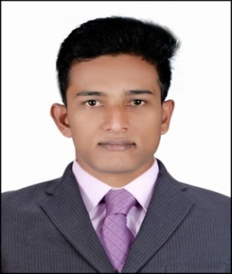
Deepak
Deepak.335661@2freemail.com

CAREER OBJECTIVE

To have a challenging position to utilize my skills and abilities to the utmost level in an organization of repute which results professional as well as organizational growth while being resourceful, innovative and unique in the firm.

WORK EXPERIENCE

- Company : Country Club (India) Ltd.
Country spa wellness Beach Resort Kovalam.
Worked as guest relation executive from 15/07/2012 to 21/01/2016
Nature of job:
Attend to guest courteously and deal promptly with their request and queries. Have detailed information about the hotel and the city. Check on VIP guest movements, complete their pre registration formalities.
Allocate rooms to all arriving guest after checking the guest preferences. Collect the guest feedback forms and do any possible.

EDUCATIONAL QUALIFICATION
SSLC in the year of March 2012
COMPUTER SKILLS
Basic Knowledge of Computer

PERSONAL PROFILE

Date of Birth : 17/07/1992
Marital Status : Single
Nationality : Indian
Visa status : visiting
Visa validity : 01/03/2017

Language Known

English, Hindi : Speak/Read/Write
Malayalam, Marathi,
Konkani : Speak

PASSPORT DETAILS

Date of Expiry : 03/08/2024
Place of Issue : Cochin.
Declaration:
I hereby declaration that all the about mentioned details are very true to the best of my knowledge.

