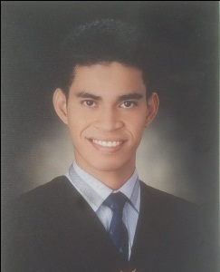

RONEL
RONEL.335664@2freemail.com

Objective:
To apply in a position suitable with my qualification and effectively utilize my knowledge and skills which will enables me to create a positive contribution to the company.

Skills:
- Under Chassis Mechanic
- Professional Driver

CAREER PROFILE
- Philippine Air Force
Villamor Air Base Pasay City
From November 2014 up to October 2016

Safety Personnel
Duties and Responsibilities

- Performs other duties that may be assigned by superiors.
- Checking of unsafe installation of equipment.
- Ensuring the safeness of the facilities.
- Checking of the condition of the vehicles.
EDUCATIONAL ATTAINMENT

PHILIPPINE STATE COLLAGE OF AERONAUTICS
Villamor Air Base Pasay City Philippines
Aviation Information Management Major in Airline Operations and Procedures
2013-2014

PASAY CITY SOUTH HIGH SCHOOL
Villamor Air Base Pasay City Philippines
2009-2010

GENERAL TINIO EAST CENTRAL SCHOOL
Brgy Conception General Tinio Nueva ecija Philippines
2000-2006

Birthday: Decembe 09 1993
Civil Status: Single
Nationality: Filipino
Religion: Roman Catholic
I hereby certify that the above information were true and correct to the best of my knowledge and ability.

