Curriculum Vitae
Zelle
Zelle.335677@2freemail.com

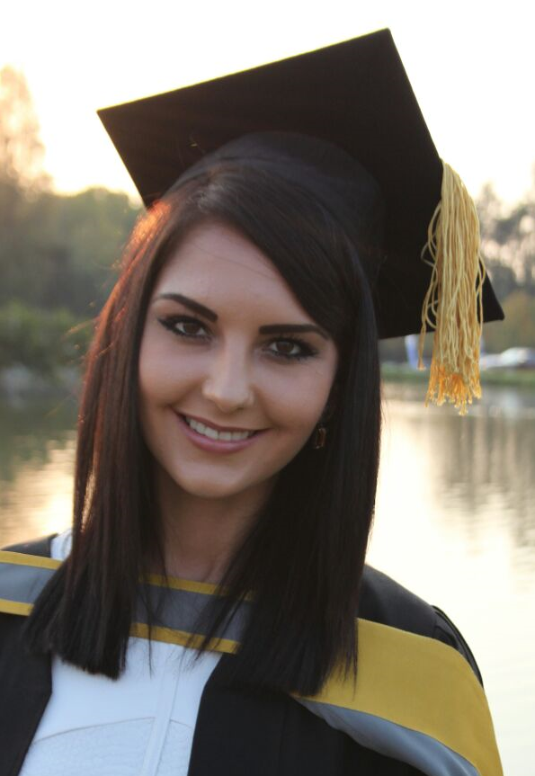

Personal information

Date of birth: 18 April 1992
Nationality: South African Citizen
(Teaching License)
Language Proficiency: Afrikaans (Home language)
English (Fully bilingual)
Marriage status: Single
Dependants: None
Health: Good
Smoker: No
Special needs: None
Driving license: Yes
Own vehicle: Yes

Educational Background and Qualifications

2012 – 2015 B.Ed. ECD- and Foundation Phase
University of Pretoria
Specialised subjects: Afrikaans, Learning support
(Financially independent studies: No bursary)

2011 B. Ed Senior Phase (First year completed)
University of Pretoria
Specialised subjects: Afrikaans, Psychology, Heritage studies
(Financially independent studies: No Bursary)

2006 – 2010 Schooling
Volksrust High School
Subjects: Afrikaans (Home Language) B
English (First Additional Language) B
Mathematical Literacies A
Life Orientation A
Geography A
Life Sciences A
Physical Sciences C

Pass senior certificate – examination with distinction and full exemption
Extra-Curricular Activities:
2010- Volksrust High School Hostel committee
Portfolio: Social

Member of the South - African – Sailing team that represented South Africa at the Dart 18 World Championships in England

2008-2010 – Participation in sport:
Hockey and athletics

2009- Winners of the KwaZulu-Natal Provincial Dart 18- Sailing Championships

General Skills

Leadership skills Student leader during practical in-service education at Rooihuiskraal Primary School
Hostel leader during matric year in Tienerhof hostel, Volksrust High School

Administration skills Duties as typist of quarterly reports, annual term plans, year plans, assessment plans and weekly lesson planning during year of employment as educator

First Aid Certificate in Level 1 First aid

Study performance 2nd place in writing of the book, Lallie land, as children’s literature during a competition presented by Macmillan Press in the core subject JGL 200

Computer skills Programs: MS Word, MS Excel, MS PowerPoint

Experience

2016 Appointed as Grade 1 educator by Cullinan Combined School, for the period 1 January 2016 until 31 December 2016. Subjects included Afrikaans (HL), English (FAL), Mathematics, Life Skills. Extra- Curricular activities included:
- U/9 Mini- Netball Coach
- U/7 Mini- Cricket Coach
- Art Instruction (Eisteddfod Cultural Competition)
- Involvement in Revue Dancing and Singing talent show
- Learning Support and Remedial education
2015 Practical experience in teaching during in- service learn in the foundation phase (grades 2 and 3) at the following Primary schools in Pretoria:
Hennopspark Primary School–
Grade 3, Quarter 2
Extra- Curricular activities: Learning support through extra classes in reading and mathematics

Rooihuiskraal Primary School-
Grade 2, Quarter 3
Extra- Curricular activities: Learning support in reading and writing and 0/7 Hockey coaching
2014 Practical experience (12 weeks) in the education of learners with physical and mental disabilities at Alma School, Pretoria, as part of community service in the methodology of learning support.
2014 Part-time work as a student for Indus HealthCare Africa, which includes duties of the design and production of theatre wear and hospital uniforms.
2013 – 2015 Work as au pair of two boys between the ages of 8 and 12, where basic au pair duties, such as transportation from Anton van Wouw Primary to extra- curricular activities and their house, support in homework tasks and basic care, were required.

2013 Preschool observation and practical experience of teaching grade R at Bergsig Pre-Primary, Newcastle.
2013 Part- time work as a student for Indus HealthCare in Mahalapye, Botswana, where the collecting and processing of data through video- recording into a documentary production on post- surgical interviews and experiences, was required.

Interests

Hobbies: World travels
Reading
Cooking
Water sport
Nature and outdoor activities

