CURRICULAM VITAE
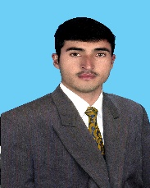

Sayed
POST APPLIED: DATA ENTRY OPERATOR, GRAPHIC DESIGNER, COMPUTER OPERATOR, SYSTEM ADMINISTRATION
E-mail id: Sayed.335713@2freemail.com
Career Objective:-
I have logic mind and methodology careful attention to details natural ability and find new challenges stimulating. I am confident that I make very positive contribution to the successful achievements of my employers goal and objective which would benefit from the skill experience and enthusiasm there I shall bring.
PASSPORT & VISA DETAIL:
Date of issue 27/06/2014
Date of Expiry 26/06/2019
Date of Birth 16/04/1991
Visa Status Visit Visa
Educational Background:
- Bachelor in science
- One year diploma in information technology
Working Experience
- Five years’ experience in pips parachinar as senior science teacher.
- Four years’ experience in Silicon Valley of information technology parachinar as Graphic designer, computer operator, Data entry operator and system administration.
Area Of expertise
- Problem solving and decision makings
- Fast learns
- Detail and accuracy oriented
- Strong work ethic
- Excellent

Certification details
- Certificate of graphic designer, data entry operator, data base, and computer operator.
- Teaching certificate PIPS Paracrine as senior science teacher.
Language Known:
- English Urdu and Hindi
Declaration:
I hereby to certify that the above information is true and correct in the best of my knowledge and belief.

