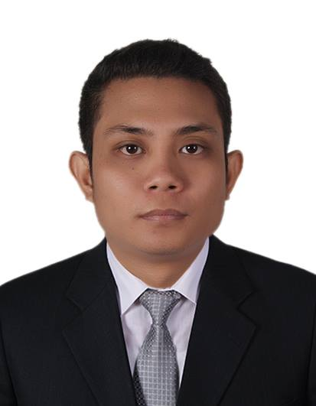

Jim
Jim.335738@2freemail.com

PERSONAL AND CAREER OBJECTIVES:

To have a full time position in a well-established institution which offers a healthy and professional working environment that enables me to grow while achieving its’ standards and goals.

PERSONAL SKILLS:

- Turning easily or readily from occupation/job to another, changeable.
- Hardworking and capable of rational conduct, trustworthy.
- Willing to learn and to be trained.
- Enjoy working/being with people.
- I am always energetic and eager to learn new skills.
- I have experience working as part of a team and individually.

EDUCATIONAL BACKGROUND:

Tertiary : Bachelor in Public Administration
City Collefe of Lucena
Barangay Isabang, Lucena City (Graduted: 2013)

Secondary : Quezon National High School
Iyam, Lucena City (Graduted: 2008)

Primary : Lucena West I Elementary School
Iyam, Lucena City (Graduted: 2003

PERSONAL PROFILE:

Date of Birth : August 26, 1991
Place of Birth: : Lucena City, Philippines
Civil Status : Single
Nationality: : Filipino
Age : 25 years old
Religion: : Roman Catholic

WORKING EXPERIENCE:

PRODUCTION OPERATOR : Canon Business Machine Philippines
December 2015 – May 2016

- Set up machines (calibration, cleaning etc.) to start a production cycle
- Control and adjust machine settings (e.g. speed)
- Feed raw material or parts to semi-automated machines
- Inspect parts with precision and measuring tools
- Test operation of machines periodically
- Fix issues that might occur during the shift
- Check output to spot any machine-related mistakes or flaws
- Keep records of approved and defective units or final products
- Maintain activity logs

VAN SALESMAN : Dranix Distributor Inc.
September 2014 – March 2015

- Achieve all assigned sales targets
- Maintain maximum customer service is displayed at all times
- To sell the company product to our current and potential customer.

ONLINE MARKETING AGENT: Global Web Marketing
June 2011 - January 2014

- Having good written and spoken communication abilities.
- Answering Emails
- Having critical thinking.
- Being able to work on several projects
- Being able to understand social media.
- Having problem solving skills at the same time.

I certify that the above information is true and correct to the best of my knowledge and believe that I shall be responsible for any falsification of this document.

